Speaking 2 KET

Name: _____________________________________________________________________ Date: _____ / _____ / __________

Objetivo: O.A 5 Presentar información en forma oral, expresando conocimiento del contenido y coherencia en la organización de ideas.

1.- Personal information

* What’s your name?
* What’s your family name?
* Can you spell your last name?
* How old are you?
* What nationality are you?
* Where do you live?
* Do you enjoy studying English? Why? Why not?
* Do you think that English will be useful for you in the future? Why? Why not?
* Do you have sibling?
* Tell me about your family.
* What are your hobbies?
* What are your plans after school?
* What are your hobbies?
* What is your favorite subject? Tell me the reason why.
* What did you do yesterday / last weekend?

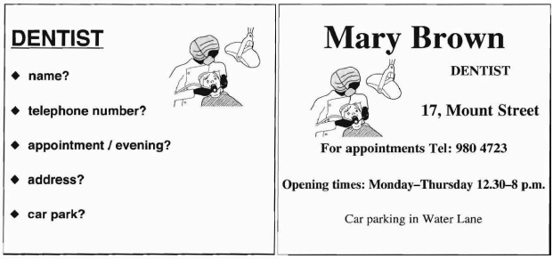



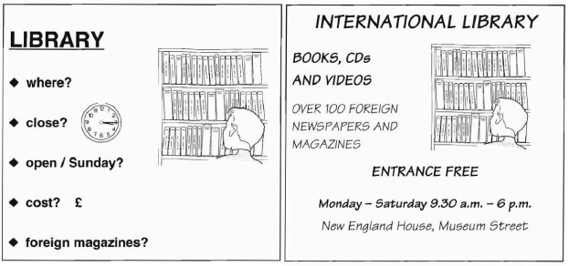

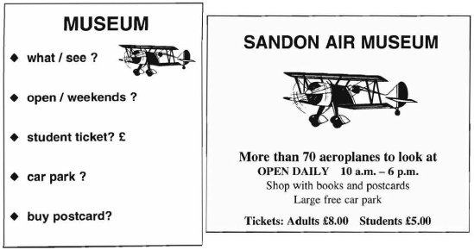

|  |  |  |  |  |
| --- | --- | --- | --- | --- |
| Criterion | Excellent  4 points | Great job  3 points | You’re almost there  2 points | Keep practicing  1 point |
| Subject-verb agreement |  |  |  |  |
| Coherence |  |  |  |  |
| Pronunciation |  |  |  |  |
| Intonation |  |  |  |  |
| Vocabulary |  |  |  |  |
|  | Total Score | _______ / 20 | Mark |  |