Guía 16 – Past Continuous and Past Simple
Objetivo OA 15 Escribir para informar, expresar opiniones y narrar, usando: Palabras, oraciones y estructuras aprendidas. Conectores aprendidos. OA 16 Demostrar conocimiento y uso del lenguaje en sus textos escritos. Describir acciones que interrumpen u ocurren simultáneamente en el pasado; por ejemplo: I was playing football, when it started to rain; while he was cycling, she was listening to music; I saw a shark while I was swimming. Unir ideas; por ejemplo: first, second, next, finally; he felt nervous before/ after the test; it's too dangerous to visit.
VER RECURSOS
Actitudes
IN07 OAA B
IN07 OAA D
Unidad 4
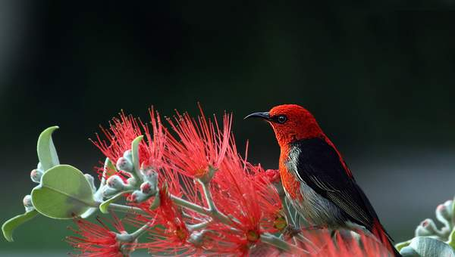
Unidad 4: Green issues
28 horas pedagógicas
Comprender textos orales y escritos acerca de los problemas del medio ambiente y el desarrollo de una mayor conciencia acerca sus cuidados.
MÁS INFORMACIÓN
Objetivos
IN07 OA 01
IN07 OA 02
IN07 OA 03
IN07 OA 04
IN07 OA 05
IN07 OA 06
IN07 OA 07
IN07 OA 08
IN07 OA 09
IN07 OA 10
IN07 OA 11
IN07 OA 12
IN07 OA 13
IN07 OA 14
IN07 OA 15
IN07 OA 16
Actitudes
IN07 OAA D
IN07 OAA E
Sitios UCE
Curriculum Nacional
Bibliotecas Escolares CRA
Biblioteca Digital Escolar
Plan de Lectura Leo Primero

Redes Sociales
- Instagram Curriculum Nacional
- Instagram BDE
- Twitter Mineduc
- Facebook Mineduc
- Youtube Mineduc
Unidad de Currículum y Evaluación
Ministerio de Educación
Teléfono +56 2 24066000
Ayuda Mineduc
Mapa del sitio
Acerca de este sitio
Políticas de Privacidad
Creative Commons
Gobierno Transparente
Solicitud de información Ley de Transparencia
Nota de la edición

Name:_________________________________________________________________________ Date:__________________

Name:_____________________________________________________________________ Date:____________________

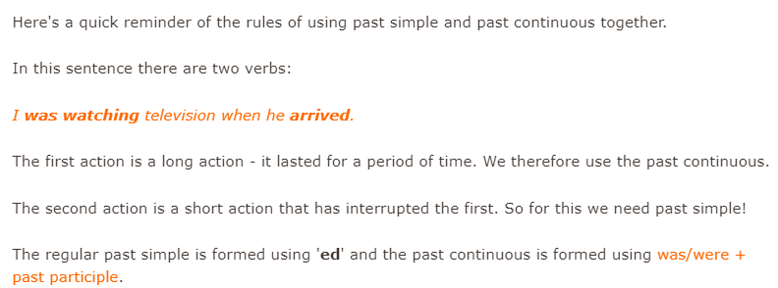

- Read the sentences and write Past Simple (PS) or Past Continuous (PC) according to the tense.

- Most of the children who played in the football match were between 10 and 12 years old
- Yesterday, the North American President asked for world peace.
- Japan was developing very important medical advances for the humanity.
- Caroline was eating an amazing tuna sandwich.
- What did you do last night? Actually, we stayed at home.
- Where was Monica studying for the test?
- What did you do yesterday?
- I was playing volleyball at the beach

- Choose which verb tense (PAST SIMPLE or PAST CONTINOUS) fits better.
(Escoja cual tiempo verbal (pasado simple o pasado continuo) corresponde en cada oración.
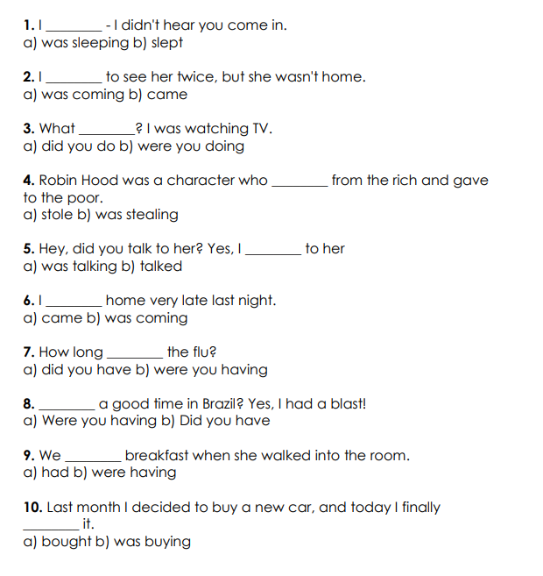

- Read the text (Lea el texto)
- Underline the verbs and write if the verb is in Past Simple form or – ing form (Past Continuous) Subrayar los verbos y escribir si el verbo esta en pasado simple o con la terminación – ing
- Answer the questions below (Responda las preguntas del texto)
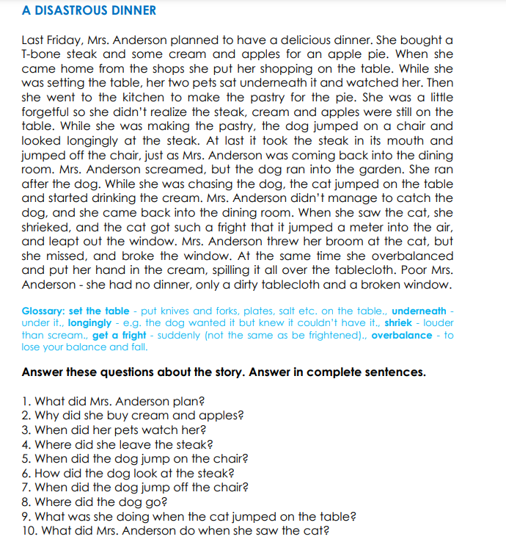

4. Complete the following sentences with the correct form (PAST SIMPLE or PAST CONTINOUS) Complete las siguientes oraciones con la forma correcta (pasado simple o pasado continuo)
