**8th GRADE ENGLISH STUDY Reading**

**Content: Places from the City.**

I. Read the next text about Sandra and the description she gives related to Hilltown and the places she can find there and answer the questions below. (Lea el siguiente texto sobre Sandra y la descripción que da relacionada con Hilltown y los lugares que puede encontrar allí y responda las preguntas a continuación.)

***“My Hometown, Hilltown”***

*“Hi Friends! My name’s Sandra and I live in Hilltown. It is in the south of England. It isn’t a very big town. About 9,000 people live here.*

*There are about thirty shops in Hilltown and there are three supermarkets. You can buy everything in the town what you need. There are two banks and a post office in Main Street. There is a police station and a library, too. You can find a big market where you can buy fresh fruit, vegetables, meat and dairy products. I like going to the market with my mum.*

*There are three churches in the town centre and there is a park, too. In the park children can play because there is a playground. In our town you can find some restaurants and there are five cafés. My favourite café is “Icecave”. It’s in Park Street and the ice cream is fantastic here! There are three elementary and two high schools in Hilltown. My school is in Mill Street. We have got a very nice building. Next to our school there is a sports centre. Every Wednesday afternoon we play badminton. If you want to see a film you can go to the cinema in our town, but unfortunately there aren’t any theatres here.*

*I like living in Hilltown because it is a calm, neat place and people are friendly.”*

I.I Answer the next questions related to the content of the text below. (I. Lea el siguiente texto sobre Sandra y la descripción que da relacionada con Hilltown y los lugares que puede encontrar allí y responda las preguntas a continuación.)

1 Where can you find Hilltown?

_____________________________________________________________________

2 How many people live in the town?

_____________________________________________________________________

3 What buildings and places can you find there?

_____________________________________________________________________

4 What is Sandra’s school like? Where is it?

_____________________________________________________________________

5 Why does she like her town?

_____________________________________________________________________

II. Find the proper meaning for each part from the city vocabulary word and link them with the description correctly. (Encuentre el significado adecuado para cada parte de la palabra del vocabulario de la ciudad y vincúlelos con la descripción correctamente.)

_____ you can eat there

_____ police officers work there

_____ doctors and nurses look after sick people there

_____ people go to buy and sell things there

_____ you go to borrow or read books there

_____ children go to learn there

_____ you go to send letters and to buy stamps there

_____ you go to see a film there

_____ people go to pray there

_____ you can buy food and other things in that big shop

a) library

b) market

c) cinema

d) hospital

e) supermarket

f) restaurant

g) school

h) post office

i) church

j) police station

III. Write the proper meaning for each word using your own description related to the picture and the vocabulary word. (Escribe el significado adecuado de cada palabra usando tu propia descripción relacionada con la imagen y la palabra del vocabulario.)



a) **Museum:** _____________________________________________



b) **Airport:** ______________________________________________

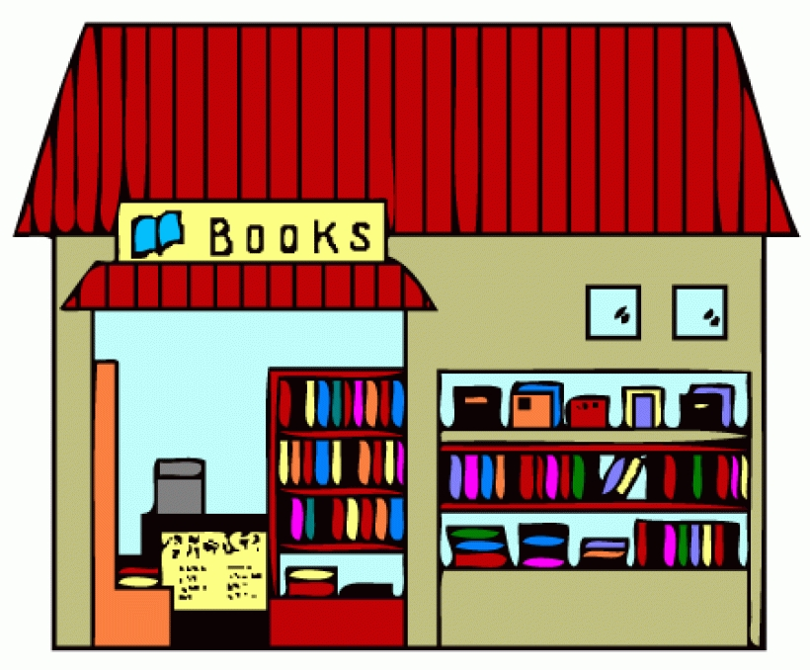

c) **Bookshop:** ___________________________________________

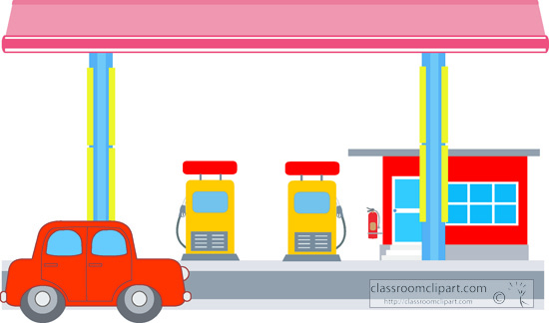

d) **Gas Sation:** ___________________________________________