Reading Nº1

Tema: **“Entrevista de trabajo”**

|  |  |
| --- | --- |
| Contenido | Entrevista de trabajo, “Compartiendo mi experiencia de trabajo” |
| Objetivo | Reflexionar sobre la actualidad de las entrevistas de trabajo en inglés y lograr crear sus propias conclusiones. |
| Instrucciones | Leer la siguiente historia acerca de una entrevista de trabajo “SHARING MY JOB EXPERIENCE” y luego responder preguntas acerca del texto.  Puede utilizar diccionario y/o cuaderno con la materia realizada en clases. |

**“*SHARING MY JOB EXPERIENCE”***

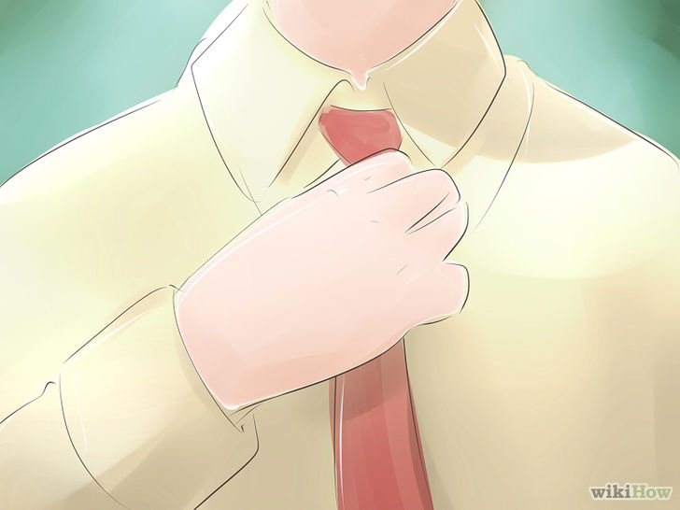Hi there! My name is Bryan and I’m here to tell you about my first experiences about job interviews. It is said that an awesome résumé gets you an interview, and a successful interview gets you an offer. Indeed, interviewing is an important skill. It involves not only expressing yourself clearly, but also communicating it to your interviewer. As a current graduate student, I have had several interview experiences. There are errors and little shining points in those experiences that I would like to share with you now.

Know Yourself

About two years ago, I had a phone interview with a big local accounting firm for a tax internship opportunity. Because this was my first formal interview, I did a lot of homework. I checked through the possible interview questions and prepared answers, while also researching the company’s background. I found the “*WikiJob*” website was quite useful for me during my preparation.



**II. Responder las siguientes preguntas relacionadas al texto. (Answer** the next questions related to the text **“*SHARING MY JOB EXPERIENCE”*** with the proper information and your opinion.)

a) According to Bryan, what it’s the meaning of “a great interview?

__________________________________________________________________________________________________________________

__________________________________________________________________________________________________________________

__________________________________________________________________________________________________________________

b) What were the actions that Bryan make for his first interview?

__________________________________________________________________________________________________________________

__________________________________________________________________________________________________________________

_________________________________________________________________________________________________________________

c) How was the first interview experience of Bryan? Why?

_________________________________________________________________________________________________________________

_________________________________________________________________________________________________________________

_________________________________________________________________________________________________________________

