Reading Nº3

Tema: Comprensiòn lectora

|  |  |
| --- | --- |
| Objetivo | Leer y comprender el texto acerca de los modales del mundo. |
| Name |  |
| Instrucciones | Lea sobre algunas costumbres en Egipto, Brasil y Alemania y responda las preguntas a continuación |

**“Manners around the world.”**

**EGYPT**

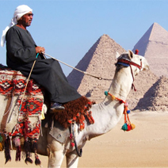“Most people in Egypt are Muslim. For this reason, many customs and traditions revolve around Islam. Family and honor are also very important in Egypt. People in Egypt are expected to dress as well as they can. It is important to **make a good impression** by wearing nice clothes. Dressing in sloppy clothes may cause the people around you to feel **awkward**. Personal grooming is also important. People shake hands with each other when they meet. Handshakes are limp, but people shake hands cheerfully. Hospitality is very important. It is part of Egyptian **tradition** to serve guests tea or coffee. If you are invited to someone's home for a meal, you should bring good quality chocolates or sweets. **Respect** for elders is a must. For this reason, people greet the oldest people first. Egyptian society is organized by social class. Class and family are more important than how much money you have. For this reason, people **avoid** socializing with those of a different group.”

**BRAZIL**

“Family and social class are most important in Brazil. People dress according to their class in Brazilian society. You are expected to dress well and wear good quality accessories. People are judged by how they look. Time is seen as something outside of one's control. Relationships are more important than sticking to the time. If you are invited to a dinner party, try to come 30 minutes late. Brazilian culture is a group culture. Avoid doing anything to **embarrass** anyone. Criticizing a Brazilian in front of others may cause **problems** for you. It will also make everyone feel awkward. Try to find a polite way to deal with disagreements. Men shake hands **firmly** when they meet. Women kiss each other lightly on the cheek. Brazilians take time to greet each other. It may take a few minutes to ask each other about their health and their families. People from Western cultures may find this frustrating because they are in a hurry. However, it is okay in Brazilian culture because Brazilians are more informal. For this reason, it is not rude to **interrupt** someone when they are talking.”

**GERMANY**

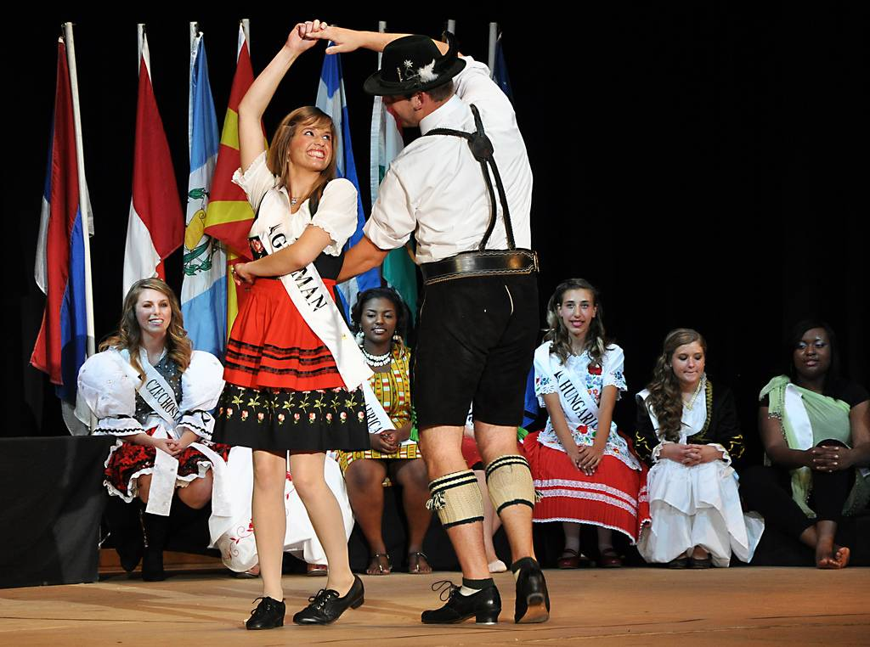“People in Germany tend to be reserved and a bit formal. Time and space are very important in German culture. Germans value their privacy. For this reason, it is bad **manners** to ask Germans about personal details such as age, income and personal beliefs. This includes politics and religion. Always knock and wait for permission to enter. It is important to be on **time** in Germany. If you have an appointment at 1:15, you should arrive at 1:15 and not a minute after. It is better to be one or two minutes early, if possible. Only close friends and family are invited to one's home. It is important to be neat and tidy at all times. People tend to look down on those who are not **organized** or behave casually. One must never litter in Germany, but throw out trash in a bin. You are also expected to clean up any mess you make right away. Shake hands with everyone, including children. If you are invited to **take part** in a meal in someone's home, arrive on time. Also, keep your elbows off the table at dinner. Written communication is important. It is polite to send thank you notes if you receive a present or are invited to a meal. It is **typical** to greet strangers in elevators and at tables, but not open spaces.”

Answer the questions related to the text **“Manners around the world”** with the information from the text and your own opinion and knowledge. (Contesta las preguntas relacionadas con el texto “Modales del mundo” con la información del texto y su propia opinión y conocimiento.)

a) How are greetings different in the three countries?

_____________________________________________________________________

b) Which country is most formal? Which is most informal?

_____________________________________________________________________

c) In which country is touching avoided? In which country do people touch often?

_____________________________________________________________________

d) What is meant by class?

_____________________________________________________________________

e) In which countries are family most important?

_____________________________________________________________________

f) What is meant by privacy?

_____________________________________________________________________

g) In which country is it alright to be late? In which country must you be on time?

_____________________________________________________________________

h) In which country is religion very important?

_____________________________________________________________________

i) What is meant by "group culture"?

_____________________________________________________________________

j) How do you express appreciation in Germany?

_____________________________________________________________________