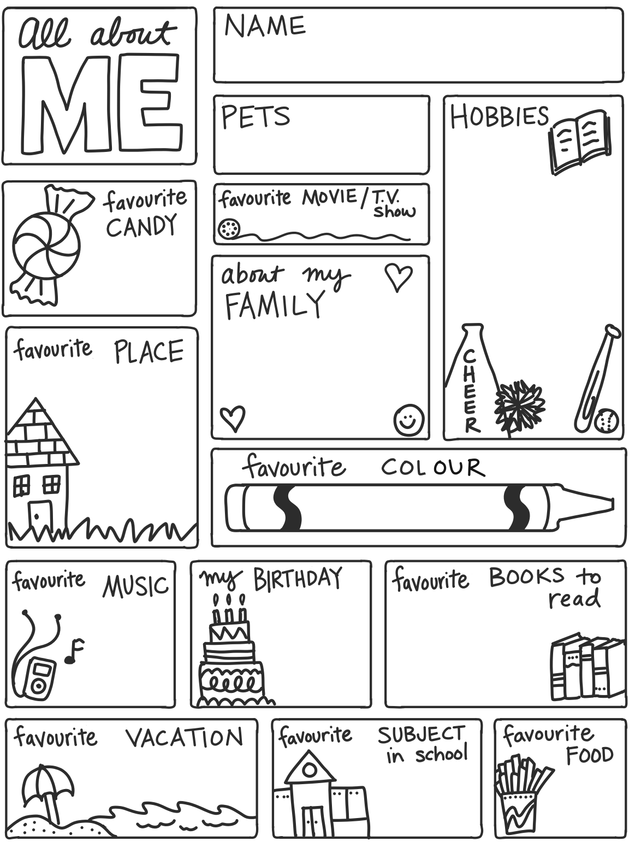

Speaking Nº1

Tema: Personal Information