Listening Nº1

Tema: “Pasado simple (Negativo – interrogativo)

|  |  |
| --- | --- |
| Objetivo | Aplicar el tiempo verbal pasado simples través de oraciones para una mejor comprensión lectora. |
| Instrucciones | Lee y observa las imágenes sobre el tiempo verbal pasado simple para luego aplicarlo en las oraciones.  Te dejo un link para que aprendas más sobre el tiempo verbal pasado simple:  <https://www.youtube.com/watch?v=wLuNOWXw96c> |

Past simple

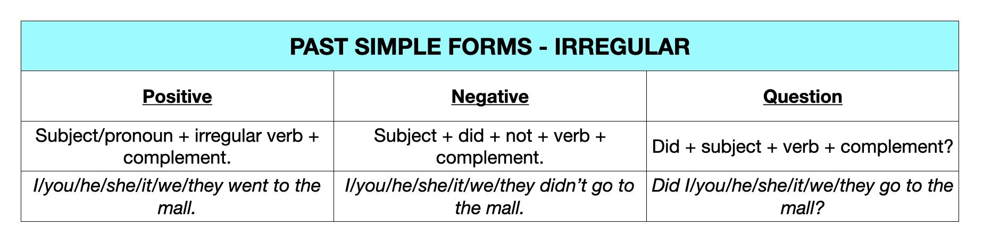

Write the verbs in brackets into the Past Simple Tense. (Escribe los verbos entre paréntesis en pasado simple.)

1. We ___________ (HAVE) a lot of fun at your

birthday party yesterday.

2. My brother and I ___________ (NOT FINISH) our homework a few minutes ago.

3. Susan ___________ (LIKE) skating when she was a girl.

4. Joe ___________ (BREAK) his leg three weeks ago.

5. I ___________ (MEET) my best friend George in 2005.

6. My parents ___________ (GO) to the theatre yesterday evening.

7. He ___________ (WATCH) a very scary horror film last night.

8. Emma ___________ (NOT GO) to school when she was ill.

9. Where ___________ you ___________ (LEAVE) your jacket?

10. ___________ you ___________ (HATE) broccoli when you were a child?

11. Peter ___________ (READ) a very interesting book yesterday.

12. Mum ___________ (MAKE) a big chocolate cake a few hours ago.

13. We ___________ (PLAY) beach volleyball when we were at the seaside.

14. He ___________ (NOT LISTEN) to music after school yesterday.

15. I ___________ (GET) lots of good marks last month.

16. ___________ they ___________ (VISIT) their grandparents last summer?

17. He was very thirsty. He ___________ (DRINK) two glasses of water.

18. Sarah ___________ (NOT ENJOY) her piano lessons when she was seven.

19. Where ___________ your father ___________ (WORK) in 1985?

20. They ___________ (SEE) lots of animals in the zoo yesterday.

II. Create 8 questions with their respective answers and then discuss them with your classmate. (crea 8 preguntas con sus respectivas respuestas y luego convérsalas con tu compañero de clases.)

1. ____________________________________________________________________
2. ____________________________________________________________________
3. ____________________________________________________________________
4. ____________________________________________________________________
5. ____________________________________________________________________
6. ____________________________________________________________________
7. ____________________________________________________________________
8. ____________________________________________________________________