Listening Nº1

Tema: Pasado Perfecto

|  |  |
| --- | --- |
| Objective | Identificar y comprender el uso del tiempo gramatical pasado perfecto. |
| Name |  |
| Instructions | Escucha el audio para comprender acerca del tiempo gramatical pasado perfecto.  <https://www.youtube.com/watch?v=SG-_Pi6zJB8> |

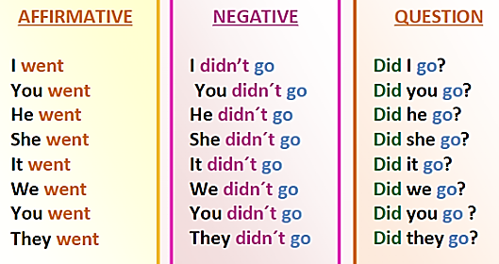**Past Simple:**

* Usamos el pasado simple para hablar de acciones realizadas completamente en el pasado.
* En el pasado simple nos encontraremos con [verbos regulares](https://www.curso-ingles.com/aprender/verbos-regulares) (terminación “-ed”) y [verbos irregulares](https://www.curso-ingles.com/aprender/verbos-irregulares).

Activity

I. Completethe next sentences by using the Simple past tense properly for each sentence form. (Complete las siguientes oraciones usando en tiempo verbal pasado simple apropiada para cada frase.)



He _________ the house. (build)

He didn’t _________ the house. (destroy)

Did he _________ in the house? (live)

a)



He _________ to work. (run)

He didn’t _________ to work. (walk)

Did he _________ on time? (arrive)

b)

She _________ Maths at my school. (teach)

She didn’t _________ Maths. (learn)

Did she _________ Math exercises? (write)

c)

**Past Perfect**:

* Lo usamos para acciones que ocurrieron antes de otra acción en el pasado.
* Se usa para acciones que ocurrieron antes de un tiempo específico en el pasado.
* Igual que en el presente perfecto, se forma el pasado perfecto con el verbo auxiliar “to have” y el participio pasado.

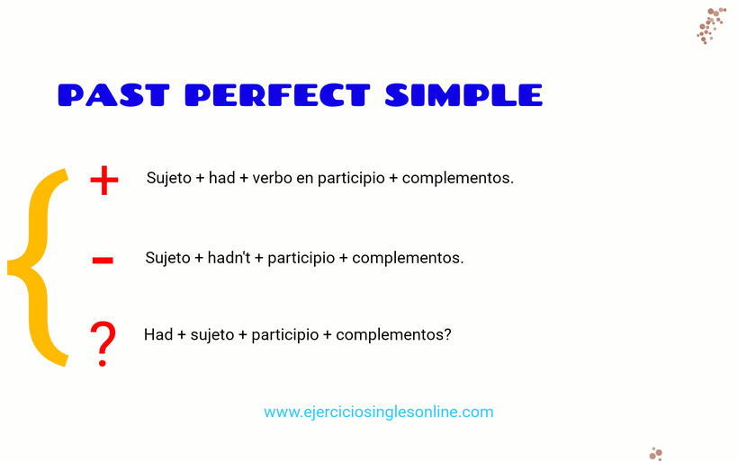

**Use:** Sometimes we talk about something that happened in the past.

* Sarah arrived at the party.

This is the starting point of the story. Then, if we want to talk about things which happened *before* this time, we use the past perfect (had done).

* When Sarah arrived at the party, Paul had already gone home.

More examples:

* When we got home last night, we found that somebody had broken into the flat.
* Karen didn’t want to come to the cinema with us because she had already seen the film.

Compare these situations:

|  |  |
| --- | --- |
| train left now  I arrived  I arrived when the train left. | train left now  I arrived  When I arrived, the train had already left. |
| “Was Tom there when you arrived?” – “Yes, but he went home soon afterwards.” | “Was Tom there when you arrived?” – “No, he had already gone home.” |

**ADVERB PLACEMENT**

The examples below show the placement for grammar adverbs such as: always, only, never, ever, still, just, etc.



Examples:

* George **had already repaired** many cars before he received his mechanic's license.
* **Had George already repaired** many cars before he received his mechanic's license?

**Form: had + past participle**

**up to then then now**

**E.g.:**

* I didn’t know who she was. I **had** never **seen** her before. (before that time). Now I know her.
* We were not hungry. We **had** just **had** lunch.

I. Put the next sentences in the right order according to the affirmative, negative and interrogative structure of the Present perfect tense sentences. (Ponga las siguientes oraciones en el orden correcto de acuerdo con la estructura afirmativa, negativa e interrogativa de las oraciones en tiempo presente perfecto.)

a) I / homework / yet / finished / haven’t / my

____________________________________________________________________

b) homework / I / my / done / already / have

____________________________________________________________________

c) ? / you / have / finished / homework / your

____________________________________________________________________

d) he / home / gone / has / already / from

____________________________________________________________________

e) Mark / come back / France / just / has / home / from

___________________________________________________________________

f) bought / they / a / house / new / haven’t

____________________________________________________________________

g) hasn’t / lunch / had / Maria / yet

____________________________________________________________________

h) the train / left / the station / already / has

____________________________________________________________________

i) three years / Jonathan / worked / there / for / has

____________________________________________________________________

j) bought / a new bike / ? / has / Peter / for / Theresa

____________________________________________________________________