Listening Nº3

Tema: “Verbo ToBe**”**

|  |  |
| --- | --- |
| Objective | Desarrollar el verbo Tobe en oraciones. |
| Name |  |
| Instructions | Escucha el video para aprender sobre el verbo To Be, luego desarrolla las oraciones completando con el verbo To Be. (AM – IS – ARE) |
| TOBE: SER O ESTAR  I am a teacher  Yo soy una profesora  You are a student  Tu eres un estudiante | <https://www.youtube.com/watch?v=i-3kGNbZUXE> |

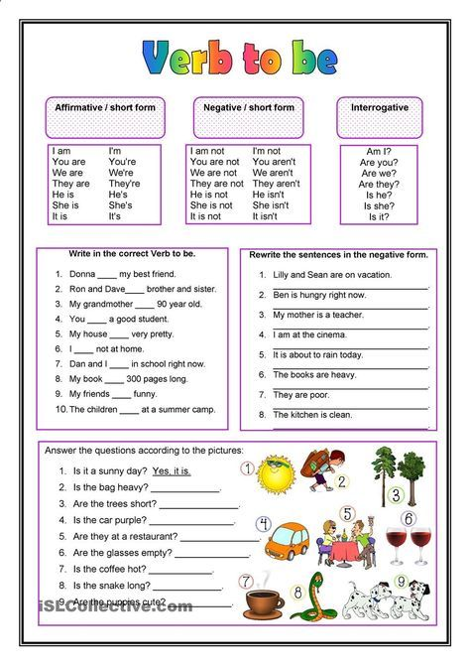

I.- Read the text and complete the sentences with verb To Be, AM – IS – ARE. (Completar las oraciones con el verbo To Be, AM – IS – ARE)



1

Hi! My name ______ Julia. I ______ from Germany. This ______ Peter. He is South African. He ______ my friend. We ______ students. He ______ in the 7th grade and I ______ in the 8th, so we ______ not in the same class. King’s College ______ our school. It ______ an old school, but we like it a lot. Our teachers ______ very nice. My favourite subject ______ Maths and Peter’s English, but I ______ also fond of Spanish and so ______ Peter. I ______ 13 years old and he ______ 12. Now we would like to hear from you. Which year ______ you in? What ______ your school like?

I.- Reescribe las frases en negative. Ejemplo: My name is not Julia.



1

Hi! My name __is__ Julia. I __am__ from Germany. This _is___ Peter. He is South African. He _is___ my friend. We _are___ students. He _is___ in the 7th grade and I __am__ in the 8th, so we __are__ not in the same class. King’s College __is__ our school. It __is__ an old school, but we like it a lot. Our teachers _are___ very nice. My favourite subject _is___ Maths and Peter’s English, but I _am___ also fond of Spanish and so __is__ Peter. I __am__ 13 years old and he _is___ 12. Now we would like to hear from you. Which year __are__ you in? What __is__ your school like?

_____________________________________________________________________________________________________________

_____________________________________________________________________________________________________________

_____________________________________________________________________________________________________________

_____________________________________________________________________________________________________________

_____________________________________________________________________________________________________________

_____________________________________________________________________________________________________________

_____________________________________________________________________________________________________________

_____________________________________________________________________________________________________________

_____________________________________________________________________________________________________________