Reading Nº2

|  |  |
| --- | --- |
| Objetivo | Aplicar el uso del tiempo verbal del pasado progresivo en diferentes frases para una mejor comprensión de lectura. |
| Name |  |
| Instrucciones | Completar las siguientes oraciones con la estructura adecuada del tiempo verbal pasado continuo en la estructura de oraciones afirmativas y el verbo entre paréntesis.  Te dejo un link para que comprendas más sobre el pasado progresivo:  <https://www.youtube.com/watch?v=mZ5ibmL8S-w&t=9s> |

Tema: “Pasado Progresivo” 02/04

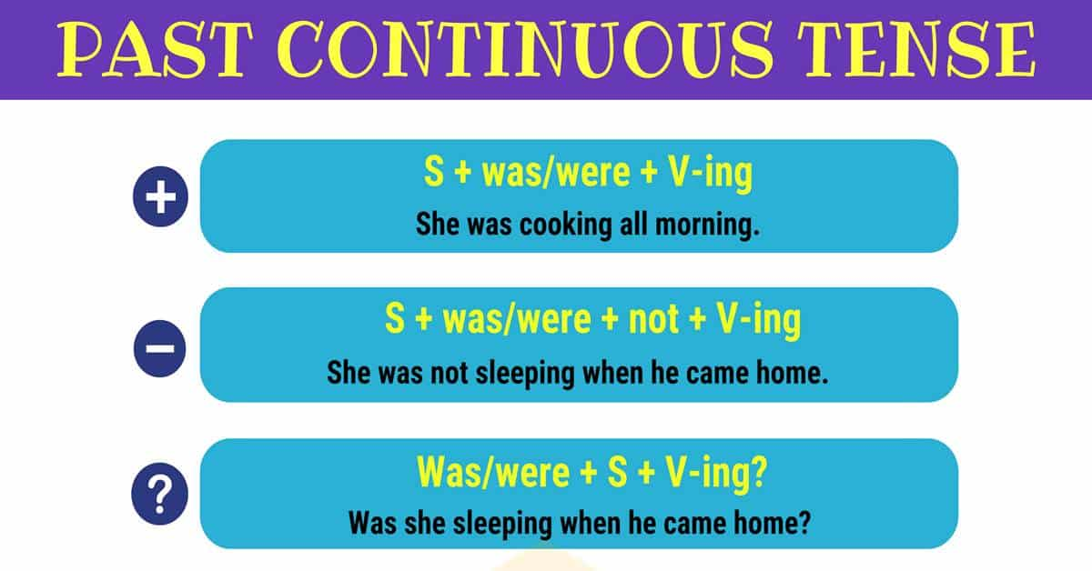

I. Completethe next sentences with the proper structure of the Past continuous verb tense in the affirmative, negative and interrogative sentence structure and the verb in brackets. (Completar las siguientes oraciones con la estructura adecuada del tiempo verbal pasado continuo en la estructura de oraciones afirmativas, negativas e interrogativas y el verbo entre paréntesis.)

1. While Rita________________ (comb) her hair, the phone _______________ (ring).
2. Ms. White _________ (be) very tired because she _______________ (look) after her patients all night last night.
3. Their houses ________________ (collapse) while they ________________ (stand) outside.
4. Everyone _________________ (wait) for watching the concert when electricity ____________ (go) out.
5. When I ________________ (climb) up the guava tree, I ____________ (see) a snake.
6. While Mike _______________ (sleep) last night, he ____________ (dream) a tiger chasing him. He _____________ (scream) and _______________ (wake) up.
7. Yesterday an elephant ______________ (run) into a food store while everyone ________________ (shop) there.
8. Beethoven _____________ (write) nine symphonies; he _____________ (compose) another when he ___________ (die).
9. What ____________________ (you/ do) at 9: 00 last night?
10. My parents _________________ (work) very hard on farm all last week. Yesterday they _____________ (decide) to stay at home.
11. Barbara __________________ (draw) while Alison _________________ (play) the piano.
12. Jeff ______________ (feel) hungry when his mother __________________ (cook) in the kitchen yesterday morning.
13. As I __________________ (watch) a stranger, he suddenly ________________ (run) away.
14. Where ______________________ (you/ live) at this time 20 years ago?
15. A lot of people __________________ (wait) for the last bus at 7.30 last night.
16. Fortunately, I ___________________ (not/ drive) too fast when the old man walked into the road.
17. When I ___________(leave) home this morning, it __________________ (rain) heavily.
18. While Mrs. Moon ___________________ (plant) seedlings in the field, she _________ (find) out a bloodsucker bleeding her leg, she ______________ (cry) out.
19. I _____________ (have) a beautiful dream last night. I _________________ (lie) on the beach. The Sun ________________ (shine). The children ___________________ (pick) up shells.
20. Our neighbors ____________________ (play) loud music all night last night, so we _______________ (cannot sleep) well.
21. While I _________________ (do) my homework, Sam ___________ (phone) and told me that he ________________ (have) some difficulties solving his problems.
22. When Reed _____________ (arrive) home, her house ____________ (be) very massive, she ____________ (not/ know) what ____________________ (happen).