Reading Nº3
Tema: Expresiones de frecuencia

Objetivo | Reflexionar sobre la actualidad de los medios de comunicación y la tecnología.
Name
Instrucciones | Conocer vocabulario y responder preguntas acerca de los medios de comunicación.

ALWAYS þþþþþþþþþþ
USUALLY þþþþþþþþ
FREQUENTLY þþþþþþþ
OFTEN þþþþþþ
SOMETIMES þþþþþ
OCCASIONALLY þþþþ
RARELY þþþ
SELDOM þþ
HARDLY EVER þ
NEVER
Adverbs of Frequency are words that tell us how often or how frequently something happens.
Adverbs of frequency come before the main verb but after “to be”.
The adverbs usually, sometimes occasionally, often, and frequently can also be placed at the beginning or end of a sentence
The adverbs seldom and rarely can also be placed at the end of a sentence.

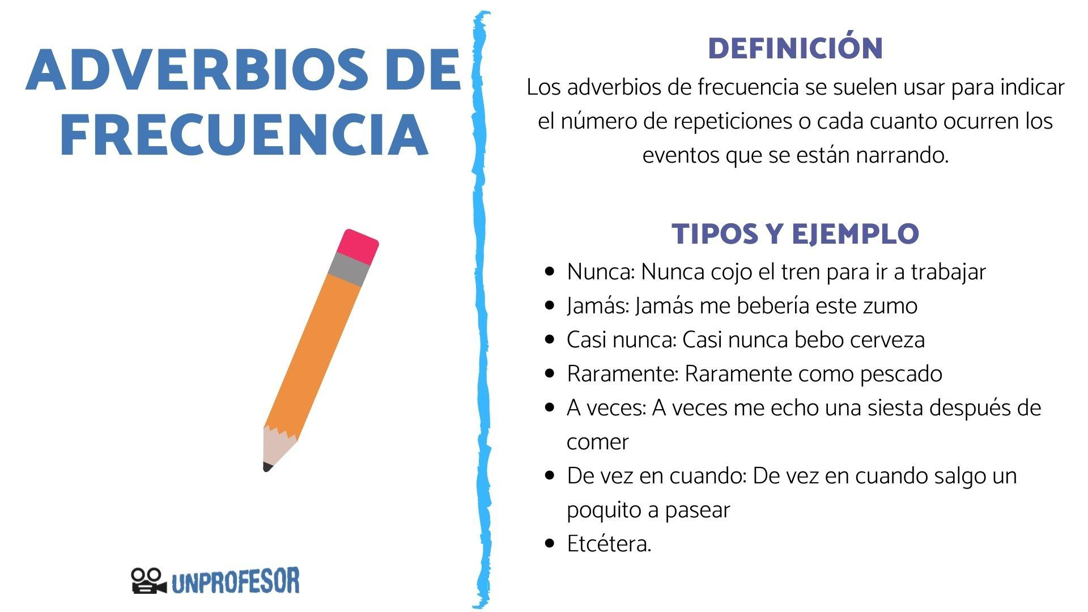

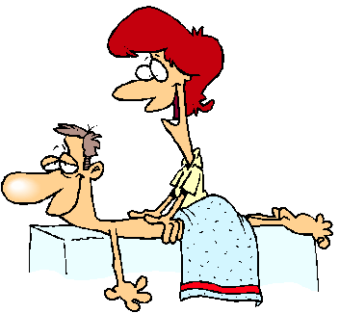

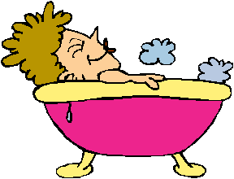
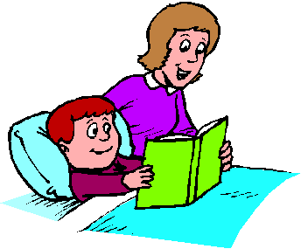
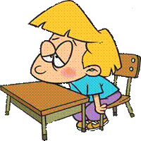
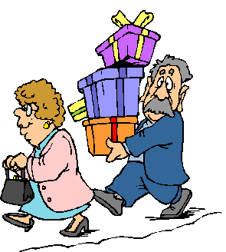
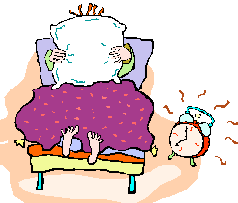
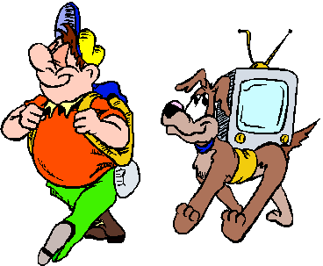
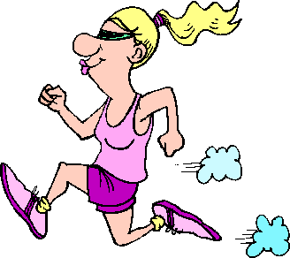


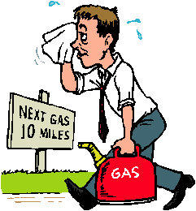
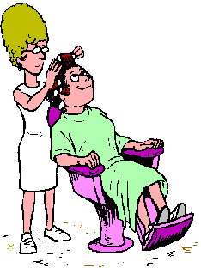
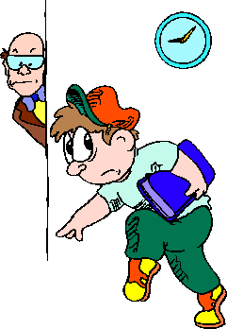


occasionally
always
never
often
usually
sometimes
usually
always
rarely
never
often
frequently
seldom
hardly ever
frequently
hardly ever

1. Mr Brinks / get / massage.
2. Frank / wake up/ when the alarm clock / ring
3. Johnny / fall asleep/class
4. Freda /go / shopping / without her husband
5. Julie and John/ have / cup of coffee/ after work.
6. The Carters / go / on picnics.
7. Kate/ get her hair/ done.
8. Bruce/go/anywhere/ without / his TV.
9. Henry / forget / to put / petrol / in the car.
10. Paula soak/ in the tub / for along time
11. Mrs. Thomas / read/ Timmy/ a story /at bedtime.
12. Allison / spend / a lot of money / shopping.
13. Stella / jog / five miles a day.
14. Mike / play/ golf / in the afternoons.
15. Adam / talk / during the lesson.
16. George / be / late / for class / in the morning.

II. Rewrite the sentences with the adverb of frequency. (Reescribe las frases con el adverbio de frecuencia)

- ______________________________________________________________________________________________________
- ______________________________________________________________________________________________________
- ______________________________________________________________________________________________________
- ______________________________________________________________________________________________________
- ______________________________________________________________________________________________________
- ______________________________________________________________________________________________________
- ______________________________________________________________________________________________________
- ______________________________________________________________________________________________________
- ______________________________________________________________________________________________________
- ______________________________________________________________________________________________________
- ______________________________________________________________________________________________________
- ______________________________________________________________________________________________________
- ______________________________________________________________________________________________________
- ______________________________________________________________________________________________________
- ______________________________________________________________________________________________________
- ______________________________________________________________________________________________________

