Speaking Nº1
Tema: Verbo Tener
Objetivo | Conocer e identificar el verbo tener.
Nombre
Instrucciones | Escribe el verbo Has o Have segun corresponda.

1) Complete with the verb to have (have or has)
a) Lucy _____ two sisters.
b) We ______ good teachers.
c) I _______ many friends.
d) They _____ good parents.
e) She ____ few and good friends.
f) He _____ a red car.
g) You _____ beautiful eyes.
h) I _______ a cat and a dog.
i) My father _____ a great job.
j) My sister ____ a boyfriend
k) He _____ black eyes.
l) The tree _____ many flowers.
m) Tom _____ a new bike.
n) I _______ a new car.
o) We _____ English class in the morning.

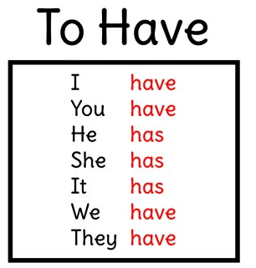

2) Check the correct alternative: (Verifica la alternativa correcta.)
a) Susan ______ a new computer.
( ) have ( ) has
b) Tom _____ a green cell phone.
( ) have ( ) has
c) My father _______ a good car.
( ) have ( ) has
d) Bob and Bill _______ a blue bike.
( ) have ( ) has
e) She _______ a TV set in her bedroom.
( ) have ( ) has
f) My parents _________ a DVD player in their bedroom.
( ) have ( ) has
g) Bete ____________ a red motorbike.
( ) have ( ) has
h) Denise and Ronald _________ a old car.
( ) have ( ) has
i) Mr Grant _______ a modern boat.
( ) have ( ) has
j) He _________ a pink bike.
( ) have ( ) has
k) I _________ two sisters and one brother.
( ) have ( ) has
l) She ________ wonderful eyes.
( ) have ( ) has
m) They _________ few friends.
( ) have ( ) has


3) Put the words in order to form sentences: (Ordena las palabras para formar oraciones)
a) I / clean / have / a / room / never.
_____________________________________________________________________________
b) House / a lot of / furniture / the / has.
____________________________________________________________________________
c) Beautiful / in / she / flowers / garden / her / has.
___________________________________________________________________________
d) English / have / new / we / book / two.
___________________________________________________________________________
4) Now mention your answers to your classmate as a conversation.
(Ahora menciona tus respuestas a tu compañero de clase como una conversación)

