Speaking Nº4

Tema: Derechos Humanos

|  |  |
| --- | --- |
| Objective | Aplicar vocabulario acerca de los derechos humanos. |
| Name |  |
| Instructions | Escriba las respuestas de los derechos humanos y coméntalas con tus compañeros de clases. |

**Content: “*Video Analysis about Human Rights*”.**

<https://www.youtube.com/watch?v=hyVJHpiHO8I>

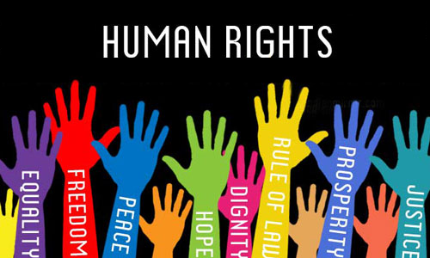

I. Describethe next human rights by your own words.

1. No Slavery ________________________________________________________________________________________

_____________________________________________________________________________________________________

1. Right to a Nationality ____________________________________________________________________________

_____________________________________________________________________________________________________

1. Social Security ___________________________________________________________________________________

_____________________________________________________________________________________________________

II. Answer the next questions with your own opinion and information from the video.

1. Do you think people should know the Human rights? Why?

__________________________________________________________________________________________________________________

__________________________________________________________________________________________________________________

1. In your opinion, which is the most important Human Right? Why?

__________________________________________________________________________________________________________________

__________________________________________________________________________________________________________________

1. Does your country promote these Human Rights? Why? How?

__________________________________________________________________________________________________________________

__________________________________________________________________________________________________________________

1. Is important to teach Human Rights in Schools? Why?

__________________________________________________________________________________________________________________

__________________________________________________________________________________________________________________

1. What would change in our lives if everyone knows their Human Rights? Why?

__________________________________________________________________________________________________________________

__________________________________________________________________________________________________________________

**IV. Create** your own meaning for the concept of “Human Rights”.

***“Human Rights are…”***

__________________________________________________________________________________________________________________

__________________________________________________________________________________________________________________

__________________________________________________________________________________________________________________

__________________________________________________________________________________________________________________

__________________________________________________________________________________________________________________

* Discuss your answers with your classmates.