Vocabulary Nº1
Tema: Comidas
Objetivo | Identificar vocabulario de comidas.
Nombre
Instrucciones | Relaciona las imágenes con las palabras del recuadro. Clasifica las palabras del cuadro en estas 4 categorías

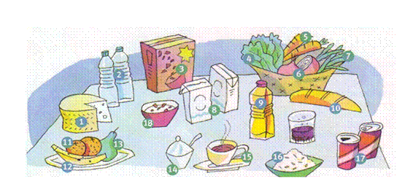
I. Match the pictures with the words in the box. (Relaciona las imágenes con las palabras del recuadro.)

water (2) coffee cereals cheese banana beans carrots oil sugar onions cola lettuce pear oranges milk bread cereal box rice

II. Classify the words in the box into these 4 categories. (Clasifica las palabras del cuadro en estas 4 categorías)

FRUIT | VEGETABLES | DRINKS | OTHER
 |  | water

III. Read these paragraphs and answer: True or False. (Lee estos párrafos y responde: Verdadero o Falso.)
My name is Amy Bradshaw and I’m 15 years old. I like large pepperoni pizzas and
chocolate ice cream. I don’t like hot dogs, but I love French fries. I hate my little brother Kenneth. He is NOT a nice boy!


True (T) or False (F)

____Amy likes chocolate ice cream

____Amy loves salads

____Amy hates her brother
Hi! My name is Kenneth Bradshaw and I’m 13 years old. I like giant hot dogs and strawberry cakes. I don’t like milk, but I love coke. I hate my sister Amy. She is NOT a nice girl!
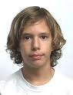
True (T) or False (F)

____ Kenneth is 15 years old

____ Kenneth doesn’t like milk

____ Kenneth likes strawberry cakes

