Vocabulary Nº2

Tema: “Lugares de mi ciudad**”**

|  |  |
| --- | --- |
| Objective | Identificar vocabulario sobre lugares de mi ciudad. |
| Name |  |
| Instructions | Observe la tabla de las “Palabras de preguntas” y así aprender cómo realizar preguntas. Luego, elija la alternativa correcta para completar las oraciones. |

**Vocabulary**

**airport** - the place you go when you want to travel by plane to another city.

**bakery**- you can buy fresh bread and cakes here.

**bank**- you deposit or withdraw/take out your money here. You can cash a cheque.

**bookstore** - a place where you can buy books and magazines.

**bus station**- the place you go when you want to travel by bus to another city.

**butcher's** - they sell fresh meat.

**café** - you can buy a cup of coffee and cakes or sandwiches.

**church**- a religious place of worship.

**court**- the place where they have trials and law cases. A judge works here.

**craft market** - a place that sells typical products (normally hand-made) of a region/country.

**department store** - a large store that sells clothes, household appliances etc. in sections.

**cinema/movies**- you can see the latest movies here. Many people eat popcorn while they're here.

**fire station**- the building where firefighers keep their equipment including the fire engine.

**gas / petrol station**- the place you go to put petrol (gas) in your car.

**gym**- you can do exercises, weight training and keep fit here.

**hairdresser's** - you go here when you want to cut your hair.

**hospital** - you go here when you need an operation or someone is going to have a baby.

**hotel**- where you sleep when you visit another city.

**gallery**- you can see paintings and other works of art.

**jail / prison**- criminals are sent here by a judge for a number of days or years.

**laundromat / launderette** - a place where you can wash your clothes in coin-operated machines.

**library** - a place where you can read and borrow books.

**museum** - you can see many old objects (and sometimes paintings)

**pharmacy/drugstore** - you can buy medicine here.

**police station** - you are taken here when you break the law and are arrested

**pub**- a place where you can buy a beer or other types alcoholic drinks

**park** - An area of public land in a city that contains an area of grass where you can rest, play or walk your dog. Sometimes children can play on swings, a slide or a climbing frame here.

**restaurant**- you go here when you don't want to cook at home. They prepare meals for you.

**school** - a place where children learn. You normally start school at the age of 5.

**square** - an open area within a city in the shape of a square. It is usually the heart of the city.

**supermarket** - a large store that sells food, drinks and household items

**zoo** - a place where you can see many types of animals in cages.

Activity

I.- Write the corresponding word under each image. Escriba debajo de cada imagen la palabra correspondiente.

school - Airport – road - library – church – restaurant - theater – hospital - supermarket – Zoo - factory

[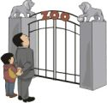](https://www.dicts.info/picture-dictionary.php?w=zoo) [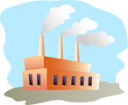](https://www.dicts.info/picture-dictionary.php?w=factory) [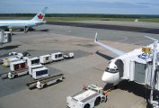](https://www.dicts.info/picture-dictionary.php?w=airport)

____________________________ ____________________________ ____________________________

[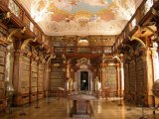](https://www.dicts.info/picture-dictionary.php?w=library) [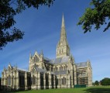](https://www.dicts.info/picture-dictionary.php?w=church) [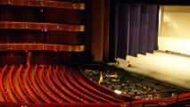](https://www.dicts.info/picture-dictionary.php?w=theater)

____________________________ ____________________________ ____________________________

[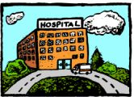](https://www.dicts.info/picture-dictionary.php?w=hospital) [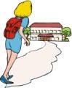](https://www.dicts.info/picture-dictionary.php?w=school) [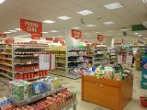](https://www.dicts.info/picture-dictionary.php?w=supermarket)

____________________________ ____________________________ ____________________________

[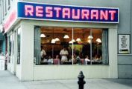](https://www.dicts.info/picture-dictionary.php?w=restaurant) [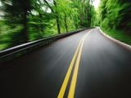](https://www.dicts.info/picture-dictionary.php?w=road)

____________________________ ____________________________

II.- Write in the crossword the vocabulary of the city according to the pictures. (Escribe en el crucigrama el vocabulario de la ciudad segun las imagenes.

