Colegio Particular Subvencionado “Sao Paulo” Asignatura: Lenguaje y Comunicación
Placilla 333, Estación Central Profesor: Luis Pineda Martínez
Unidad Técnico Pedagógica Curso: 7º Básico

Unidad 1: “El Héroe y el Antihéroe en la Narración”
Gramática 2: “Uso de Adverbios”

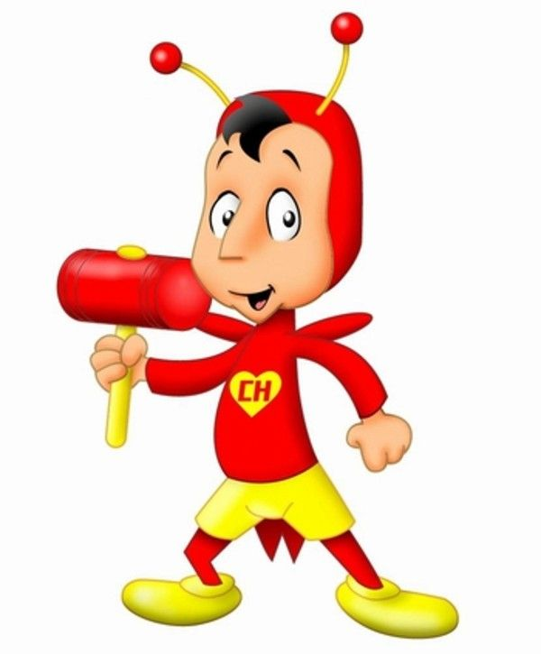
Actividad 1: Crea un cuento utilizando los siguientes adverbios. El cuento debe relatar la historia del Chapulín como antihéroe. Crea un título y usa toda tu imaginación y creatividad. A medida que vayas creando tu cuento, subraya los adverbios.
Aquí – ahora – mal – menos – cierto – nunca – quizás

Título del Cuento: ___________________________________________________________________________
_____________________________________________________________________________________________________________________________________________________________________________________________________________________________________________________________________________________________________________________________________________________________________________________________________________________________________________________________________________________________________________________________________________________________________________________________________________________________________________________________________________________________________________________________________________________________________________________________________________________________________________________________________________
_________________________________________________________________________________________________________________________________________________________________________________________________________________________________________________________________________________________________________________________________________________________________________________________________________________________________________________________________________________________________________________________________________________________________________________________________________________________________________________________________________________________
_________________________________________________________________________________________________________________________________________________________________________________________________________________________________________________________________________________________________________________________________________________________________________________________________________________________________________________________________________________________________________________________________________________________________________________________________________________________________________________________________________________________
_______________________________________________________________________________________________________________________________________________________________________________________________________________________________________________________________________________________________________________________________________________________________________________________________________________

Nombre del Estudiante: ____________________________________________________________________________

Actividad 2: Crea un poema utilizando los siguientes adverbios. Tu poema dedicado a un héroe que tú conozca (puede ser real o ficticio) en cuatro estrofas, de cuatro versos cada uno. Cuando termines una estrofa, sáltate dos espacios para la estrofa siguiente. Usa la rima libre. Usa los siguientes conectores y subráyalos a medida que vayas usándolos.
Ahí – mañana – despacio – casi – sí – nunca –acaso

Título del Poema: ___________________________________________________________________________
_________________________________________________________________________________________________________________________________________________________________________________________________________________________________________________________________________________________________________________________________________________________________________________________________________________________________________________________________________________________________________________________________________________________________________________________________________________________________________________________________________________________
_________________________________________________________________________________________________________________________________________________________________________________________________________________________________________________________________________________________________________________________________________________________________________________________________________________________________________________________________________________________________________________________________________________________________________________________________________________________________________________________________________________________
_________________________________________________________________________________________________________________________________________________________________________________________________________________________________________________________________________________________________________________________________________________________________________________________________________________________________________________________________________________________________________________________________________________________________________________________________________________________________________________________________________________________
_________________________________________________________________________________________________________________________________________________________________________________________________________________________________________________________________________________________________________________________________________________________________________________________________________________________________________________________________________________________________________________________________________________________________________________________________________________________________________________________________________________________
______________________________________________________________________________________________________________________________________________________________________________________________________________________________________________________________________________________________________________________________________________________________________________________________________________

Nombre del Estudiante: ____________________________________________________________________________

