Reading Nº2

Tema: “Verbos Irregulares”

|  |  |
| --- | --- |
| Objective | Identificar y comprender los verbos. |
| Name |  |
| Instructions | Te dejo un link para que aprendas más sobre los verbos regulares e irregulares:  <https://bristolenos.com/2017/06/21/lista-de-verbos-mas-importantes-en-ingles-regulares-e-irregulares/> |



Los verbos regulares son aquellos que no cambian su raíz a la hora de conjugarlos, en cambio los verbos irregulares sí tienen alteraciones en su raíz en algunas de sus formas.

II. Put the verbs into the correct section. Use your dictionary if needed. (Coloca los verbos en la sección correcta. Utilice su diccionario si es necesario.)

|  |  |  |  |  |  |  |
| --- | --- | --- | --- | --- | --- | --- |
| Come  Feel  Fly  Sell  Design  View | Buy  Hope  Try  Learn  Become  Develop | Stay  Translate  Continue  Create  Play  Grow | Bring  Jump  Find  Teach  Miss  Connect | Wish  Watch  Follow  Talk  Forget  Smile | Sit  Swim  Own  Give  Begin  Cook | Understand  Study  Cost  Cut  See  Cry |

|  |  |
| --- | --- |
| Regular | Irregular |
|  |  |
|  |  |
|  |  |
|  |  |
|  |  |
|  |  |
|  |  |
|  |  |
|  |  |
|  |  |
|  |  |

1. Add more verbs to the list. (Agregue màs verbos a las lista.)

|  |  |
| --- | --- |
| Regular | Irregular |
|  |  |
|  |  |
|  |  |
|  |  |
|  |  |
|  |  |
|  |  |
|  |  |
|  |  |
|  |  |
|  |  |

1. Observe this pictures and create a sentence with the use of the verbs. (Observe las siguientes imágenes y crea una oración con el uso de los verbos.)



a) (Feel): ________________________________________________

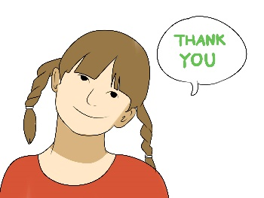

b) (Sound): ______________________________________________

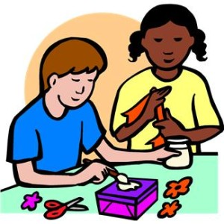

c) (Look): _______________________________________________



d) (Think): ______________________________________________

* **Crea 10 frases en tu cuaderno usando los verbos aprendidos.**