Speaking Nº2

Tema: “Tiempo verbal Presente Simple**”**

|  |  |
| --- | --- |
| Objetivo | Aplicar el tiempo gramatical presente simple. |
| Instrucciones | Lea y aprenda sobre el presente simple en sus tres modificaciones (afirmati- negativo- interrogativo). Luego, escribe el verbo en presente simple y su verbo auxiliar correspondiente.  Te dejo este link para que aprendamos más sobre el tiempo verbal presente simple:  <https://www.youtube.com/watch?v=nvVdIJ0las0> |

Simple Present

**Form**

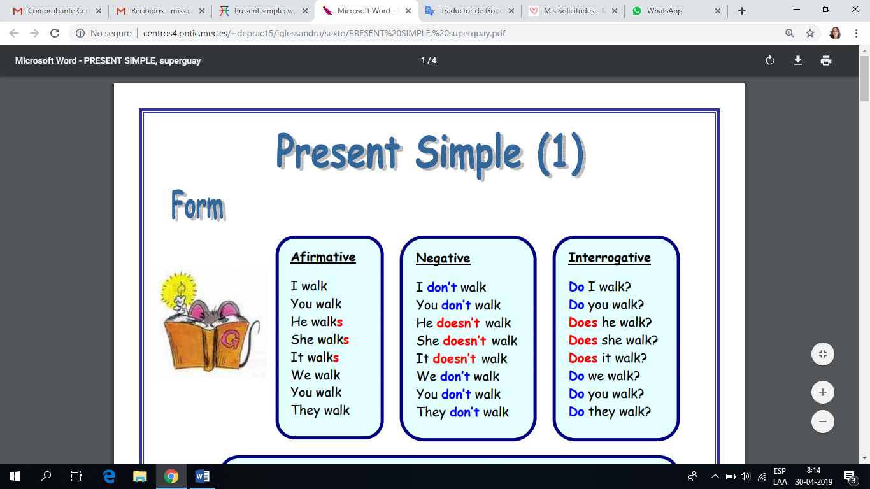

We use the Simple Present for habits and general truths.

Usamos el Presente Simple para los hábitos y las verdades generales.



Simple Present

* Always, usually, often, sometimes, rarely, never.
* Every day, in the morning, in the afternoon, at night, etc.
* On Mondays, on Fridays, at the weekend.

I.- Write the verbs in the Simple Present Tense and auxiliary verb. (Escribe el verbo en presente simple y su auxiliar correspondiente.)

1. Mary __________________________________ (play) with her friends on Fridays.
2. My mum __________________________________ (cook) delicious foods.
3. My brother __________________________________ (not let) me use his computer.
4. __________________________________ (they like) mashed peas?
5. Jason and Erica __________________________________ (live) at a beautiful village.
6. We __________________________________ (visit) my grandparents every week.
7. My sister rarely __________________________________ (tidy) her room.
8. We __________________________________ (not go) out on weekdays.
9. __________________________________ (my dad drive) to home from school?
10. My mother __________________________________ (not help) me do my homework.
11. Choose the correct answer. (Elige la respuesta correcta.)



1. Lukas his bedroom after school.
   1. tidy b) tidies
2. you play guitar in a band?
   1. Does b) Do
3. Helena your big sister?
   1. Is b) Are
4. Marcus a turtle and a cat.
   1. have b) has
5. Anita watching films at the cinema.
   1. loves b) love
6. Correct the mistakes in the sentences. (Corrige los errores en las oraciones.)
7. Tom go to school at 9 o’clock every day.
8. My house are very old.
9. Emma study a lot at the weekends.
10. Domas and Marius goes to the library.

* Escribe en tu cuaderno 10 frases usando el tiempo gramatical presente simple.