Writing Nº5
Tema: Preposiciones de lugar
Objective | Identificar las preposiciones de lugar.
Nombre
Instructions | Completa las frases con las preposiciones de lugar.

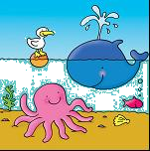  1 | Fill in the the blanks by using IN, ON, UNDER, BETWEEN.  - The fish is ______ the sea.  - The bird is ______ the ball.  - The ball is ______ the bird.  - The octopus is ________ the ball.
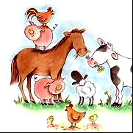  2 | Fill in the the blanks by using IN, ON, UNDER, IN FRONT OF, BETWEEN, NEXT TO.  - The horse is ______ the pigs  - The sheep is ______ the cow and the horse.  - The cock is ______ the pig.  - The chicken is _________ the chicks.  - The cow is ________ the horse.
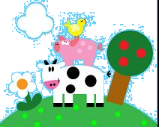  3 | Fill in the the blanks by using IN, ON, UNDER, NEAR, BETWEEN  - The pig is ______ the cow.  - The pig is _______ the bird.  - The pig is ________ the cow and the bird.  - The cow is _________ the tree.

