**Taller N 6 Lenguaje verbal**

**Vocales.**

|  |
| --- |
| **NOMBRE:** |
| **FECHA:** |

* Pinta sólo la vocal O.

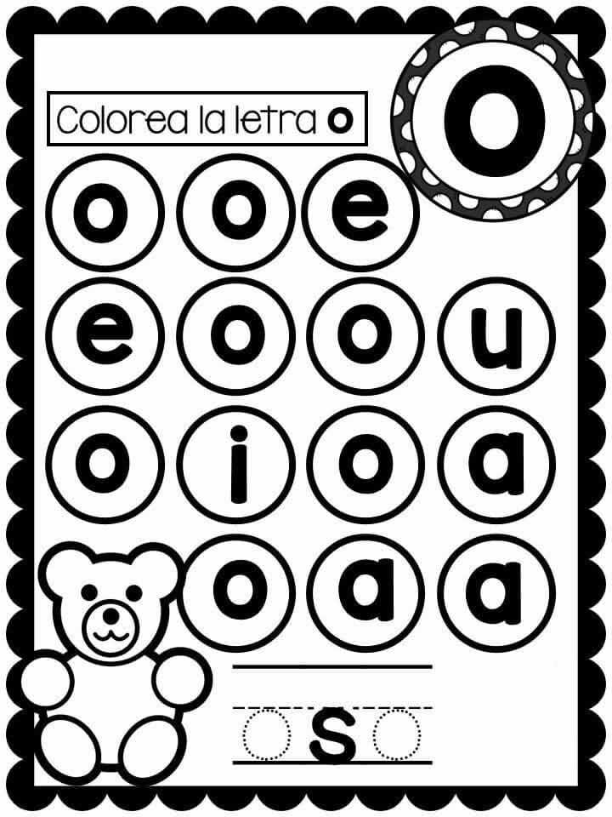

- Une la vocal O con el elemento que corresponda.

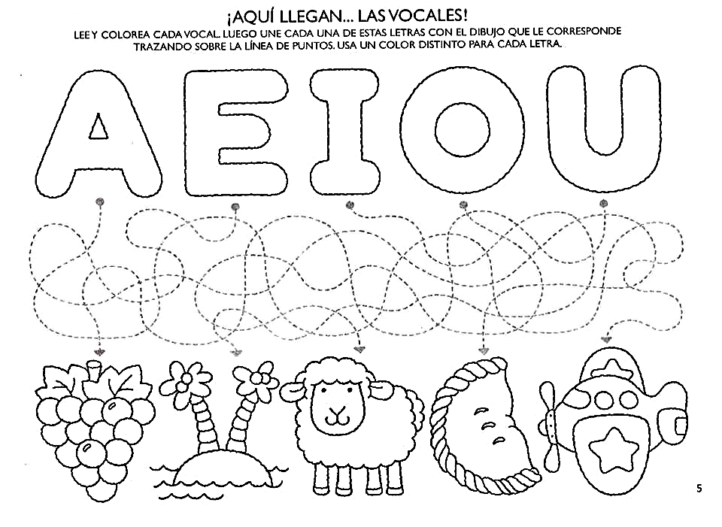 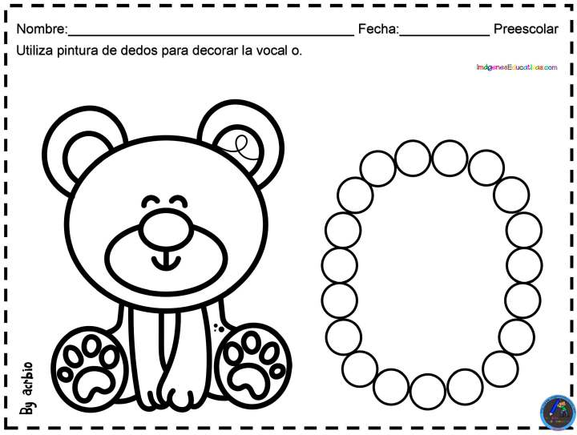

**O o**

 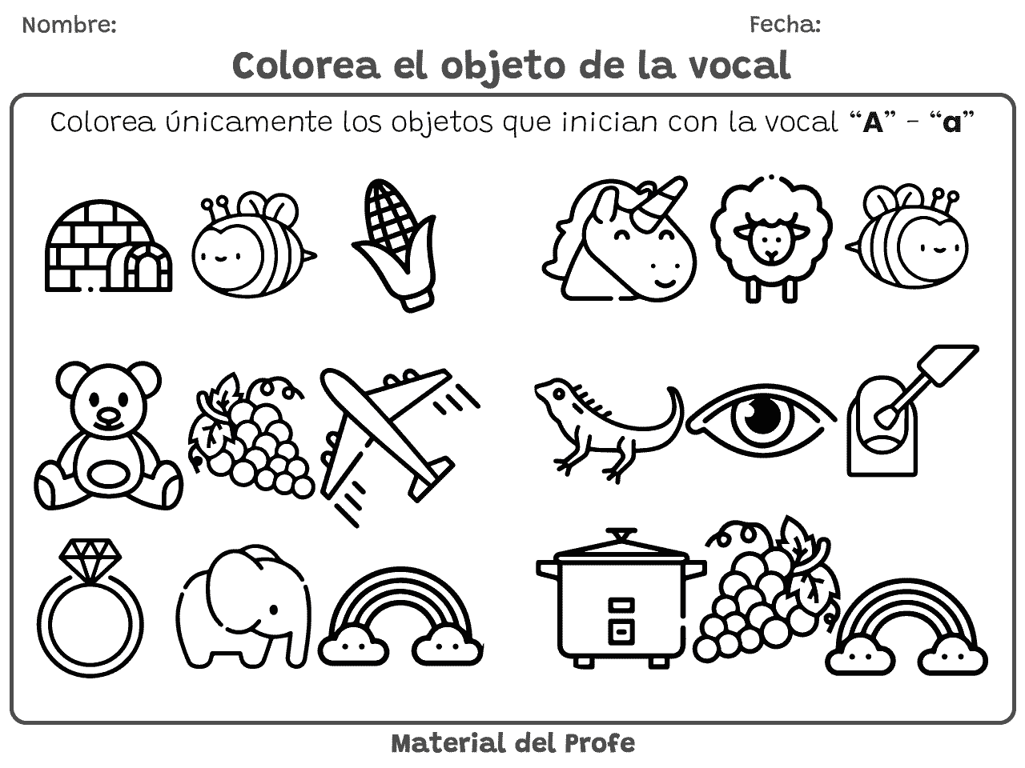

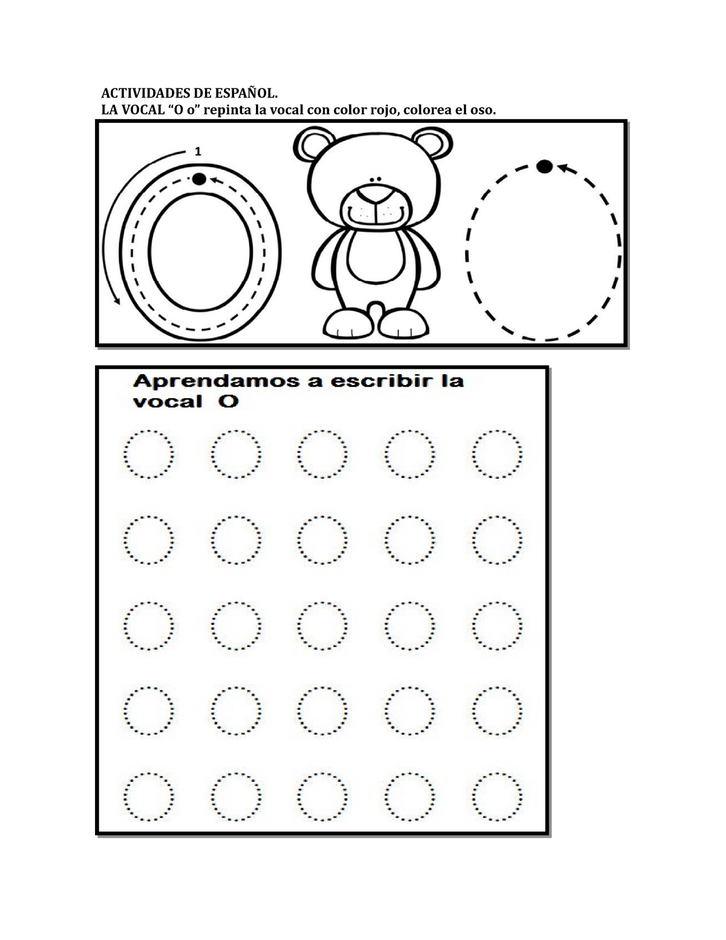

* Completa por las líneas punteadas.

|  |  |  |  |
| --- | --- | --- | --- |
| O | O | O | O |
|  |  |  |  |

|  |  |  |  |
| --- | --- | --- | --- |
| O | O | O | O |
|  |  |  |  |

|  |  |  |  |
| --- | --- | --- | --- |
| O | O | O | O |
|  |  |  |  |

|  |  |  |  |
| --- | --- | --- | --- |
| O | O | O | O |
|  |  |  |  |