Reading Nº4

|  |  |
| --- | --- |
| Objective | Identificar y comprender el uso de los condicionales. |
| Name |  |

Tema: “Condicionales”



El uso del condicional significa que una acción depende de otra. Los condicionales se utilizan para hablar sobre situaciones reales o irreales. En general, las frases condicionales llevan la palabra “if” (si). Ten en cuenta que no existe un tiempo verbal para el condicional en inglés como existe en español.

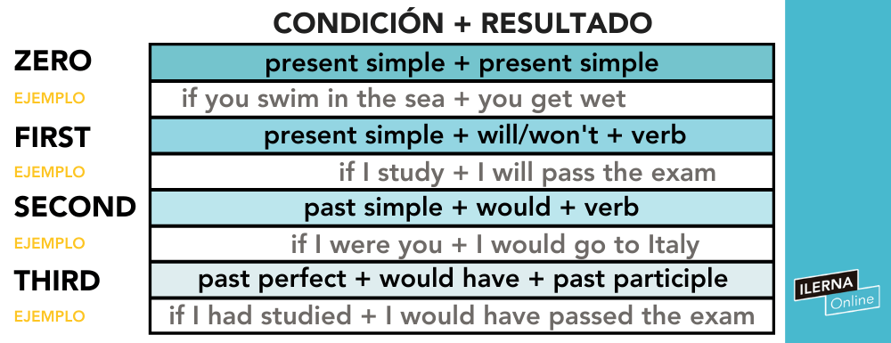

**Zero CONDITIONAL**

A) If Raphael is upset, ________ to him. (talk – imperative)

B) Metals expand if you ________ them. (heat – present)

C) Water ________ if the temperature reaches 100º Celsius. (boil – present)

D) If the temperature is below zero, water __________. (freeze – present)

E) If you feel sick, ________ a doctor. (call – imperative)

F) If the bus ______________ soon, take a taxi. (come -negative/present)

**FIRST CONDITIONAL**

If it .............. (be) Maria’s birthday, I ............................. (give) her a present. 

If you …………… (come) to my party, you ..................... (dance) a lot. 

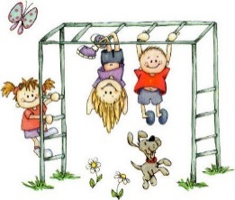

If it ....................... (not/be) sunny today, we …………………. (not/go) to the park.

If you …………………. (work) hard at school, you ...................................... (learn) a lot.

**SECOND CONDITIONAL**

a) If I **would have / had** more time, I would read more.

b) The children **would do / did** it better if they had more time

c) If he **wouldn’t be / wasn’t** so shy, he would go to parties.

d) If I were rich, I **would travel / travelled** around the world.

e) She would get the job if she **would speak / spoke** English.

f) If I **knew / would know** the answer, I would tell you.

g) If Mary had his cellphone number, she **would phone / phoned** him.

h) If Tom **would go / went** to class, he would learn more.

i) If she **wouldn’t water / didn’t water** the plants, they would die in a week.

j) If I got promoted, I **would throw / threw** a big party.

**Third CONDITIONAL**

A) If he __________________ earlier, he wouldn’t have missed the flight. (arrive)

B) If they had looked for the book, they ____________________ it. (find)

C) I _____________________ if he hadn’t talked to me. (cry)

D) The old man would have explained your dream if you _________________ him about it. (tell)

E) If she had become the president of the company, I ______________________ fired. (be)

F) If he ___________________ to Europe last year, he would have seen his favorite band show. (travel)