Speaking Nº2
Tema: “Adverbios de Frecuencia”

Objective | Aplicar los adverbios de frecuencia según gustos de compañeros.
Name

Tick the boxes and add a classmate’s name. (Marca las casillas y agrega el nombre de un compañero de clase.)

How often do you...? | never | hardly ever | sometimes | often | always
  play tennis |  | (Anna)
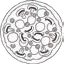
eat pizza
go camping 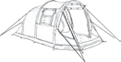
get up early
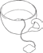
drink tea
go to museums 

read books

go running
watch television 
play board games 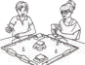
eat vegetables 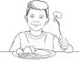
listen to music 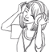
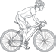
ride a bike
go to restaurants 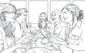
tidy your bedroom 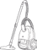
go swimming 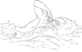

Example: How often do you play tennis?
Subject |  | + | adverb |  | + | main verb
I |  | + | never/hardly ever/ sometimes/often/always |  | + | play | tennis.
 | never | hardly ever |  | sometimes |  | often | always
0% |  |  |  |  |  |  | 100 %

- ______________________________________________________________________
- ______________________________________________________________________
- ______________________________________________________________________
- ______________________________________________________________________
- ______________________________________________________________________
- ______________________________________________________________________
- ______________________________________________________________________
- ______________________________________________________________________
- ______________________________________________________________________
- ______________________________________________________________________
- ______________________________________________________________________
- ______________________________________________________________________
- ______________________________________________________________________
- ______________________________________________________________________
- ______________________________________________________________________
- ______________________________________________________________________

