Vocabulary Nº 5

Tema: “Comida saludable y comida no saludable**”**

|  |  |
| --- | --- |
| Objective | Identificar, leer y escribir vocabulario acerca de la comida saludable y comida no saludable. |
| Name |  |

I. Look at the food and read. (Observa la comida y lee su significado)

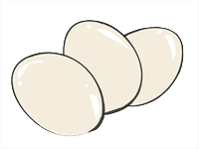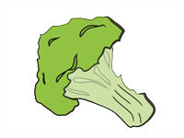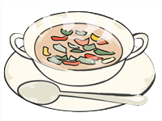

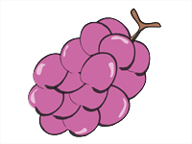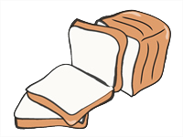

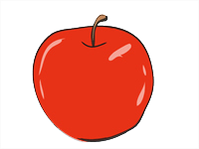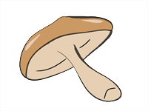

**f)** broccoli

**g)** lollipop

**e)** soup

**a)** **eggs**

**d)** grapes

**b)** ice-cream

**c)** bread

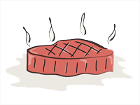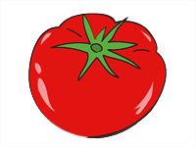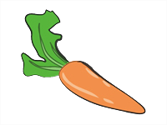

**m)** mushroom

**l)** juice

**n)** apple

**k)** meat

**j)** tomatoe

**i)** cake

**h)** carrot

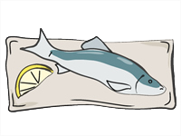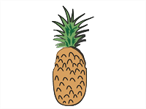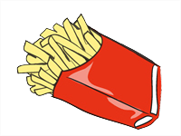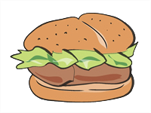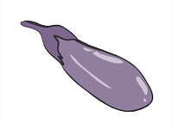

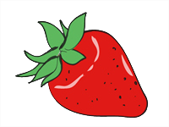

**u)** pineapple

**s)** fish

**r)** hamburger

**p)** strawberry

**t)** fries

**q)** eggplant

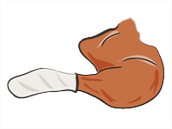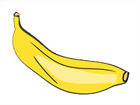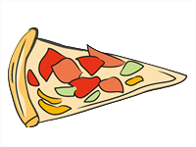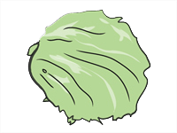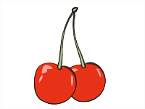

**y)** banana

**z)** chicken

**x)** pizza

**w)** cherry

**v)** lettuce

II. Match the pictures with the words in the box. (Une las imágenes con las palabras en el cuadro, escribiendo su número correspondiente)

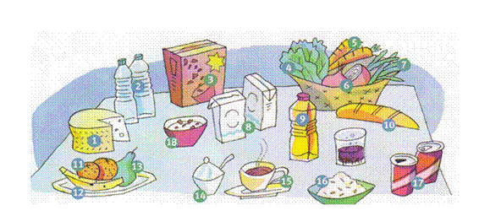

Ex: water (2) coffee cereals cheese banana beans carrots oil sugar onions cola lettuce pear oranges milk bread cereal box rice

III. Classify the words in the box into these 4 categories. (Clasifica las palabras en el cuadro de estas 4 categorías)

|  |  |  |  |
| --- | --- | --- | --- |
| **FRUIT** | **VEGETABLES** | **DRINKS** | **OTHER** |
| Banana |  |  |  |
|  |  |  |  |
|  |  |  |  |
|  |  |  |  |
|  |  |  |  |
|  |  |  |  |
|  |  |  |  |

IV. Read these paragraphs and answer: True (T) or False (F). (Lea estos párrafos y responda: Verdadero (T) o Falso (F))

My name is Amy Bradshaw and I’m 15 years old. I like large pepperoni pizzas and

chocolate ice cream. I don’t like hot dogs, but I love French fries. I hate my little brother Kenneth. He is NOT a nice boy!

_______ Amy likes chocolate ice cream

_______ Amy loves salads

________ Amy hates her brother

III. Write correct words of each food. (Escribe la palabra correcta de cada alimento.)

