**Guía N 16 Pensamiento matemático.**

**Números del 1 al 5 (pictórica y simbólica).**

|  |
| --- |
| **NOMBRE:** |
| **FECHA:** |

* Completa los siguientes recuadros de manera simbólica.

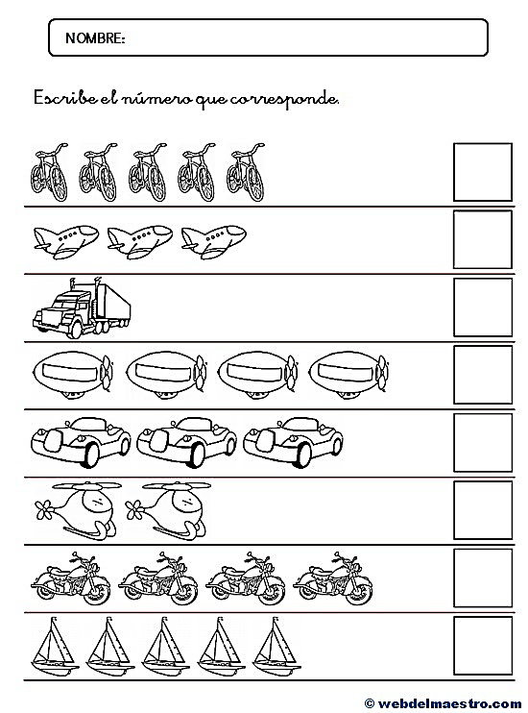

* Completa los siguientes recuadros de manera pictórica.

|  |  |  |  |  |  |  |  |
| --- | --- | --- | --- | --- | --- | --- | --- |
| |  |  |  | | --- | --- | --- | |  |  |  | |  |  |  | | 5 |
| |  |  |  | | --- | --- | --- | |  |  |  | |  |  |  | | 3 |
| |  |  |  | | --- | --- | --- | |  |  |  | |  |  |  | | 1 |
| |  |  |  | | --- | --- | --- | |  |  |  | |  |  |  | | 2 |
| |  |  |  | | --- | --- | --- | |  |  |  | |  |  |  | | 4 |

* Completa los siguientes recuadros de manera simbólica.

|  |  |  |  |  |  |  |  |
| --- | --- | --- | --- | --- | --- | --- | --- |
| |  |  |  | | --- | --- | --- | |  |  |  | |  |  |  | |  |
| |  |  |  | | --- | --- | --- | |  |  |  | |  |  |  | |  |
| |  |  |  | | --- | --- | --- | |  |  |  | |  |  |  | |  |
| |  |  |  | | --- | --- | --- | |  |  |  | |  |  |  | |  |
| |  |  |  | | --- | --- | --- | |  |  |  | |  |  |  | |  |

|  |  |  |  |  |  |  |  |
| --- | --- | --- | --- | --- | --- | --- | --- |
| |  |  |  | | --- | --- | --- | |  |  |  | |  |  |  | |  |
| |  |  |  | | --- | --- | --- | |  |  |  | |  |  |  | | 5 |
| |  |  |  | | --- | --- | --- | |  |  |  | |  |  |  | |  |
| |  |  |  | | --- | --- | --- | |  |  |  | |  |  |  | | 2 |
| |  |  |  | | --- | --- | --- | |  |  |  | |  |  |  | |  |