Reading Nº8

Los animales y sus características

Objetivo: comprender texto acerca del hábitat de los animales.

Instrucciones: leer el texto luego escribe la mayoría de adjetivos que encuentres en el texto.

**I.** Read carefully the next text about Fast animals and their description called “Fastest Animals from the world”. (Lee atentamente el siguiente texto sobre los animales rápidos y su descripción llamado “Los animales más rápidos del mundo”.)

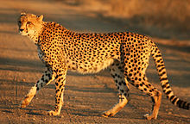*“Fastest animals from the world”*

The Cheetah

The cheetah is a big cat in the subfamily Feline that inhabits most of Africa and parts of Iran. It is the only extant member of the genus Acinonyx. The cheetah can run as fast as 109.4 to 120.7 km/h, faster than any other land animal.

It covers distances up to 500 m in short bursts, and can accelerate from 0 to 96 km/h in three seconds.

The cheetah's chest is deep and its waist is narrow. The course, short fur of the cheetah is tan with round black spots measuring from 2 to 3 cm across, affording it some camouflage while hunting. There are no spots on its white underside, but the tail has spots, which merge to from four to six dark rings at the end. The tail usually ends in a bushy white tuft. The cheetah has a small head with high-set eyes. Black "tear marks" running from the corner of its eyes down the sides of the nose to its mouth keep sunlight out of its eyes and aid in hunting and seeing long distances. Its thin and fragile body makes it well-suited to short bursts of high speed, but not to long-distance running.

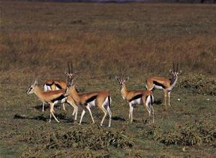

The Gazelle

Gazelles are known as swift animals. Some are able to run at bursts as high as 97 km/h, or run at a sustained speed of 48 km/h. Gazelles are mostly found in the deserts, grasslands, and savannas of Africa; but they are also found in southwest and central Asia and the Indian subcontinent. They tend to live in herds and will eat less coarse, easily digestible plants and leaves.

The 19 gazelle varieties can be split into two species, Thomson’s gazelle and Grant’s gazelle. The slight physical variations between gazelle types are determined by habitat. Mountain gazelles are smaller, for example. Both species of gazelle are tawny in color with brown and white markings and both have permanent horns. Grant's gazelles typically stand around 2 1/2 feet tall, while the Thomson’s gazelle is around 2 feet at the shoulder. Gazelles are lean, agile and strong with permanent horns. Most animals are sprinters or marathon runners, capable of either short bursts of explosive speed or sustained periods of moderate speed. A gazelle can outrun a cheetah, if he spots the predator in time, by weaving and cutting back to force the cheetah to break its sprint.

II. Complete the chart with the information from the text “Fast animals from the world” related to the adjectives of each animal. (Completa el cuadro con la información del texto “Animales rápidos del mundo” relacionada con los adjetivos de cada animal.)

|  |  |
| --- | --- |
| Adjetives | |
| ***The cheetah*** | ***The Gazelle*** |
|  |  |