**Taller N 11 Lenguaje verbal**

**“Vocales”.**

|  |
| --- |
| **NOMBRE:** |
| **FECHA:** |

* Colorea la letra inicial de cada objeto.

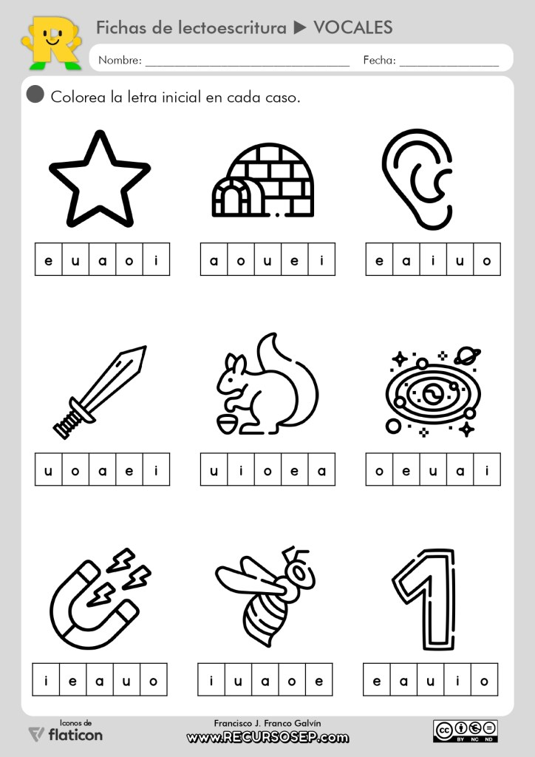

**A**

**E**

**I**

**O**

**U**

**A**

**E**

**I**

**O**

**U**

**A**

**E**

**I**

**O**

**O**

**I**

**A**

**E**

**E**

**A**

**I**

**A**

**E**

**I**

**O**

**U**

**A**

**E**

**I**

**O**

**A**

**E**

**I**

**U**

**U**

**U**

**U**

**O**

**O**

**U**

**O**

**U**

**I**

**E**

**A**

* Une cada objeto con su vocal inicial.

O

U

E

I

A

* Pinta las vocales según instrucciones.

A: Azul.

E: Verde.

I: Amarillo.

O: Rojo.

U: Anaranjado.

* Completa los siguientes trazos.

|  |  |  |  |  |  |  |
| --- | --- | --- | --- | --- | --- | --- |
| A | A | A | A | A | A | A |
|  |  |  |  |  |  |  |

|  |  |  |  |  |  |  |
| --- | --- | --- | --- | --- | --- | --- |
| E | E | E | E | E | E | E |
|  |  |  |  |  |  |  |

|  |  |  |  |  |  |  |
| --- | --- | --- | --- | --- | --- | --- |
| I | I | I | I | I | I | I |
|  |  |  |  |  |  |  |

|  |  |  |  |  |  |  |
| --- | --- | --- | --- | --- | --- | --- |
| O | O | O | O | O | O | O |
|  |  |  |  |  |  |  |

|  |  |  |  |  |  |  |
| --- | --- | --- | --- | --- | --- | --- |
| U | U | U | U | U | U | U |
|  |  |  |  |  |  |  |