Reading Nº 4

Tema: Expresión de posesión (Have – Has)

|  |  |
| --- | --- |
| Objective | Comprender texto oral acerca de expresiones de posesión. |
| Name |  |

I. Read carefully the next text about Stephen and his family going to the grocery store called “Going to the grocery store with my family”. (Lea atentamente el siguiente texto sobre Stephen y su familia yendo al supermercado llamado “Yendo al supermercado con mi familia”.)

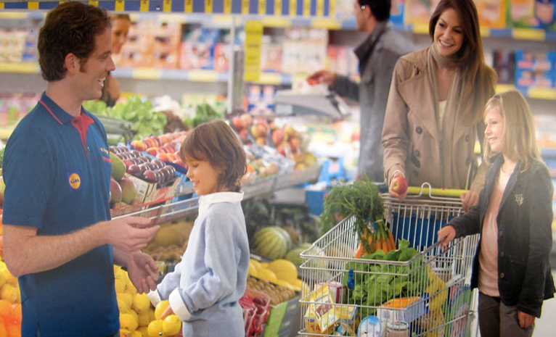

“Going to the grocery store with my family”

“My name is Stephen and it is Sunday morning, the day of the week that my family and I always go to the grocery store and have our week’s grocery orders of fruit and vegetables for our own. The first place to go is the fruit’s place, where my mom always collects twelve oranges, three pineapples, ten apples and five oranges, also my dad takes seven peaches for his own and five bunches of grapes. My sister and I love to go to the vegetable’s place, because our mom has taught to us the importance of a healthy lifestyle. My sister checks the grocery store’s list and chooses to collect eight carrots, five onions, eleven potatoes and nine tomatoes. My part is to collect six boxes of mushrooms, seven lemons and three lettuces.

After we go to the fruits and vegetables place, we take a break and visit our favorite Sunday Hobby of all time for lunch, our family and I go to “Granny’s delicious” shop, where we can eat many delicious things, for example, my Dad always choose a hamburger, two hot dogs and a can of soda, my mom and my sister like to be on fit, so they always choose the “light” menu, which contains a glass of juice, 2 salads of their choice and a dessert, pretty good in my opinion, but I prefer the kid’s menu, that is a great offer of this place, here I can eat 2 hot dogs, a glass of soda and a bag of French fries, my mom says “your stomach will be hurt” but my dad always answer “it’s Sunday, let’s have some fun!”.

2. Answer the next questions related to the text “Going to the grocery store with my family” using the proper structure of the sentence and the verbs “Have” and “has” respectively. (Responde las siguientes preguntas relacionadas con el texto “Going to the grocery store with my family” utilizando la estructura adecuada de la oración y los verbos “Have” y “has” respectivamente.)

**a)** How many oranges does Stephen’s mom have?

_____________________________________________________________________

**b)** How many carrots does Stephen’ sister have?

_____________________________________________________________________

**c)** How many boxes of mushrooms do I have?

_____________________________________________________________________

**d)** How many peaches does Stephen’s dad have?

_____________________________________________________________________

**e)** How many tomatoes does Stephen’ sister have?

_____________________________________________________________________

3. Create questions related to the next statements related to the text “Going to the grocery store with my family” using the proper structure of them. (Crea preguntas relacionadas con las siguientes afirmaciones relacionadas con el texto “Ir al supermercado con mi familia” utilizando la estructura adecuada de las mismas.)

a) _____________________________________________________?

He has a hamburger

b) _____________________________________________________?

They have two salads

c) _____________________________________________________?

He has two hot dogs

d) _____________________________________________________?

He has a bag of French fries