Reading Nº5

Tema: Sports, Hobbies and Leisure Activities.

|  |  |
| --- | --- |
| Objective | Identificar vocabulario del deporte y aplicarlo en frases. |
| Name |  |

I. Write the correct vocabulary meaning for each picture related to Sports, hobbies and leisure activities and create a phrase/sentence with each vocabulary word. (Escribe el significado de vocabulario correcto para cada imagen relacionada con deportes, pasatiempos y actividades de ocio y crea una frase/oración con cada palabra de vocabulario.)



a) ____________________ / ________________________________



b) ____________________ / ________________________________

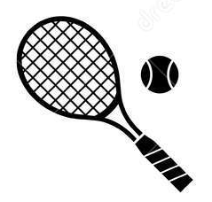

c) ____________________ / ________________________________



d) ____________________ / ________________________________



e) ____________________ / ________________________________

II. Answer the next questions related to your activities made in your free time about sports, hobbies or leisure activities. (Responde las siguientes preguntas relacionadas con las actividades que realizas en tu tiempo libre sobre deportes, aficiones o actividades de ocio.)

a) What do you do in your free time on Friday?

_____________________________________________________________________

b) What do you do in your free time on Saturday?

_____________________________________________________________________

c) What do you do in your free time on Sunday?

_____________________________________________________________________

III. Read the next text carefully about Hassan and his interesting hobby and answer the following questions. (Lee atentamente el siguiente texto sobre Hassan y su interesante afición y responde las siguientes preguntas.)

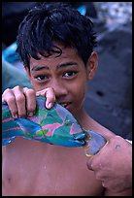

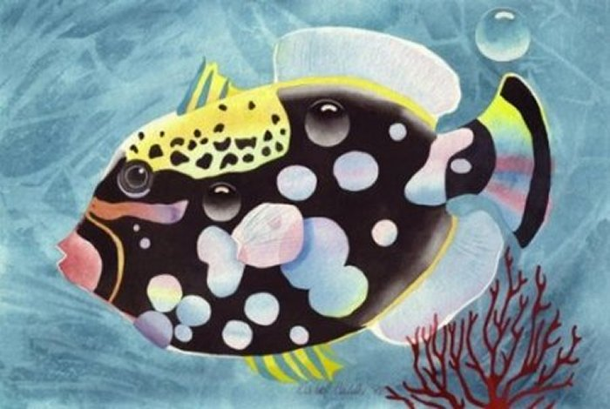

*Hassan has a very interesting hobby. He collects tropical fish! His bedroom has a gigantic aquarium all around the wall. He has been collecting fish since he was four. His first fish was an Angel fish. The only problem is that they can eat smaller fish. Hassan has visited a lot of different countries like Australia to dive in the beautiful weather there. He has always loved the ocean. Now, he’s fourteen. He has had his big aquarium for three years, since he was eleven.*

*Last year when Hassan was in Caribbean for his holiday, he saw sharks when he was diving. He wants to have an aquarium where he can keep one or two small sharks, but it’s quite difficult in England. He works as a volunteer at the aquarium of his local zoo. There he can feed the big fish. He hasn’t fed the sharks yet, because he is too young.*

a) What does Hassan collect?

_____________________________________________________________________

b) Where does he have a huge aquarium?

_____________________________________________________________________

c) How old is Hassan?

_____________________________________________________________________

d) Where did he see big sharks when he was diving?

_____________________________________________________________________

e) Can he feed sharks now?

_____________________________________________________________________