Writing Nº7

Tema: Past simple, regular verbs.

|  |  |
| --- | --- |
| Objective | Identificar y describir los números del 20 al 100. |
| Name |  |

I. Connect the verb, the object, and the picture. (Conecta el verbo, el objetivo y la imagen.)

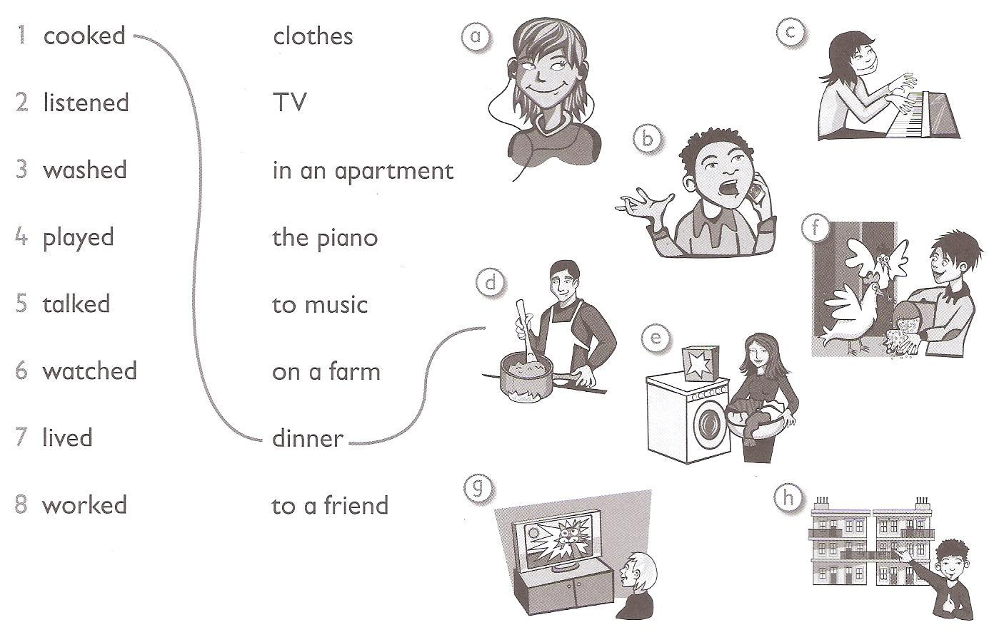

II. Read the sentences and draw.

(Lee las oraciones y dibuja.)

They watched TV yesterday.



She listened to music last night.



We played soccer.



I cooked the dinner.