Listening Nº4

Tema: Pasado perfecto

Objetivo: aplicar el uso de la estructura del tiempo gramatical pasado perfecto sobre la vida cotidiana.

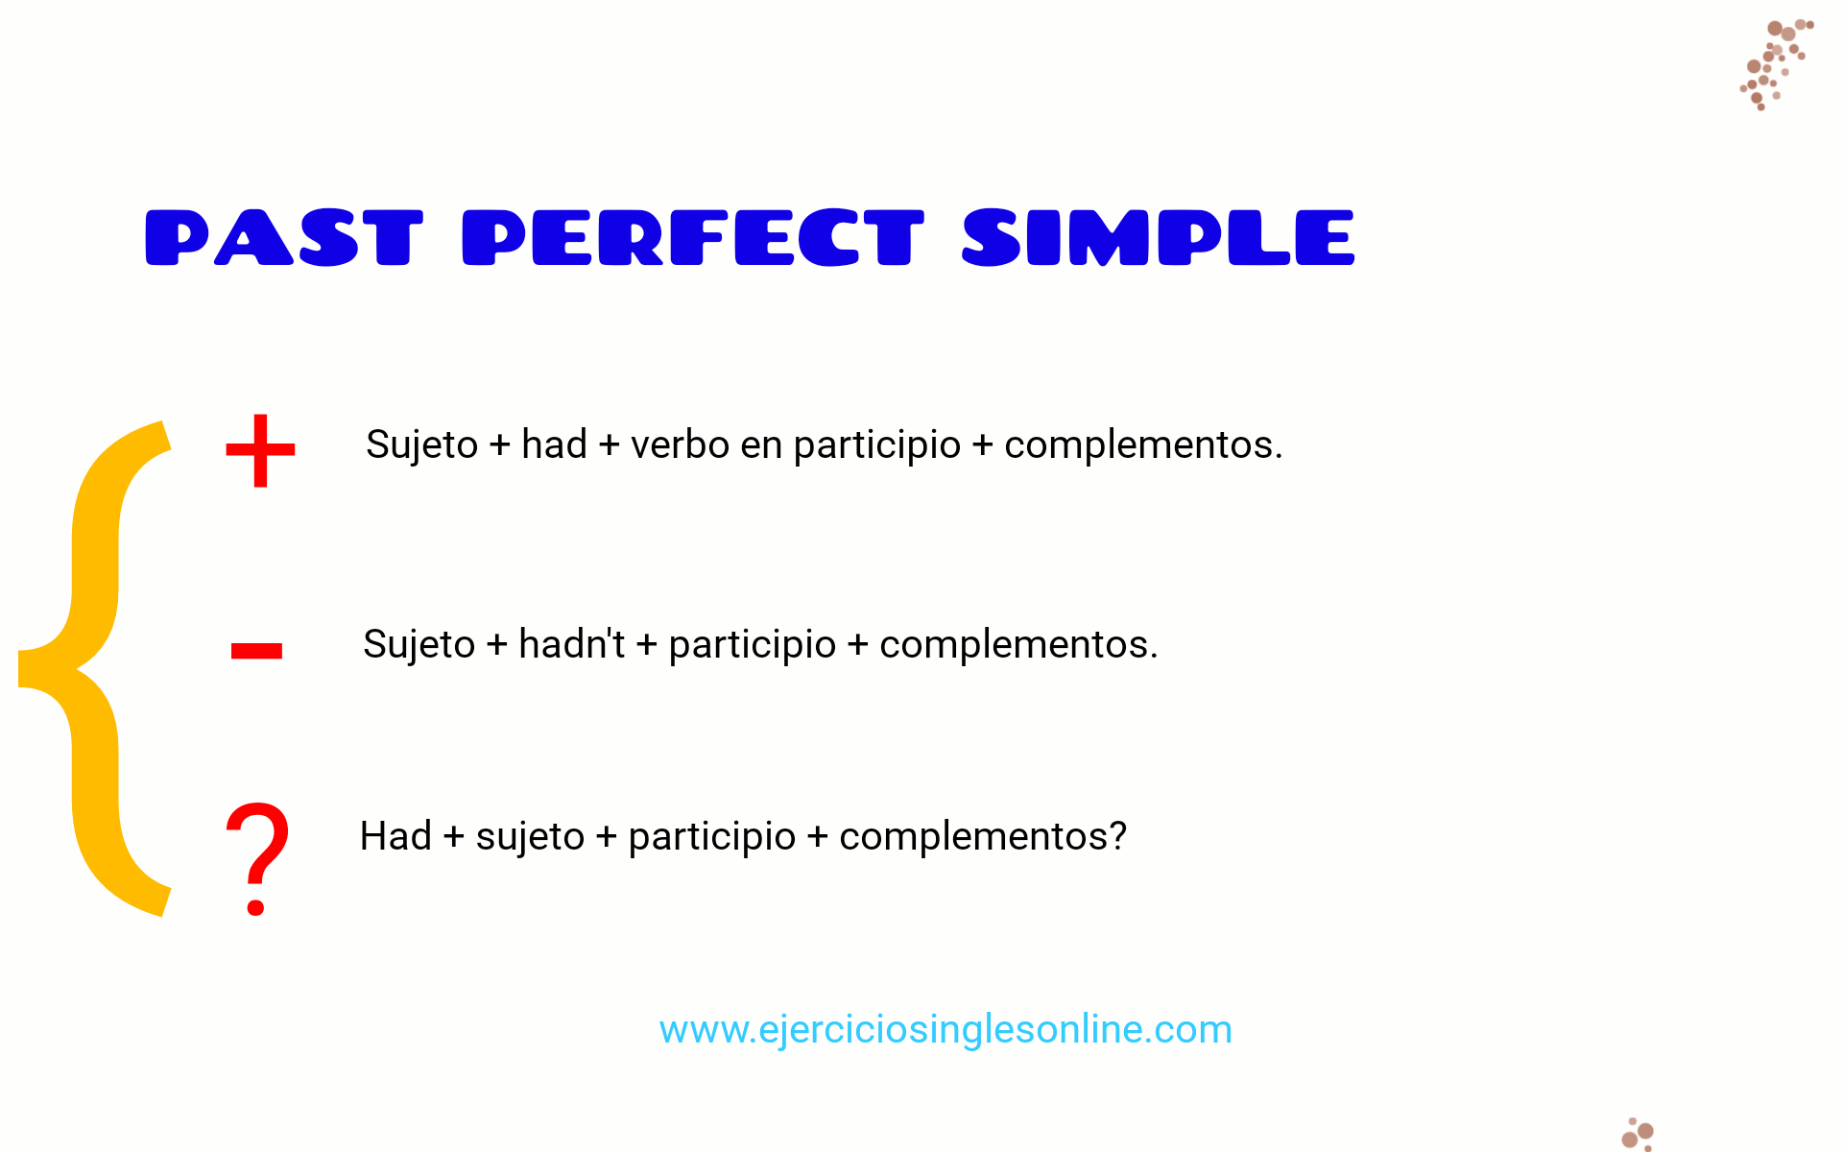

**Ejercicio 1: Completa las oraciones con la forma correcta del pasado perfecto.**

1. By the time the meeting started, everyone __________ (finish) reading the report.
2. They __________ (not/decide) on a venue before the invitations were sent.
3. After we __________ (eat), we went for a walk by the river.
4. She __________ (never/experience) such a challenging exam before she took the final test.
5. The students __________ (complete) their project before the deadline was extended.

**Ejercicio 2: Responde las preguntas utilizando el pasado perfecto.**

1. Why did they miss the concert? (buy tickets late) → They missed the concert because they __________.
2. How did you feel after the exam? (study all night) → I felt exhausted because I __________.
3. Why was she disappointed with the results? (not practice enough) → She was disappointed because she __________.
4. What happened after the teacher arrived? (students leave) → By the time the teacher arrived, the students __________.
5. Why was the house flooded? (leave the window open) → The house was flooded because they __________.

**Ejercicio 3: Corrige los errores en las siguientes oraciones.**

1. By the time I had arrived, the show had already start.
2. She had be to London twice before moving there.
3. They had not been see him for years when they met again.
4. We had went to bed by the time the phone rang.
5. After the movie finished, we had go out for dinner.

**Ejercicio 4: Traduce al inglés utilizando el pasado perfecto.**

1. Cuando llegamos a la estación, el tren ya había salido.
2. Nunca había visto un lugar tan bonito antes de ese viaje.
3. Después de que todos se habían ido, cerré la puerta.
4. Había estudiado mucho antes de rendir el examen final.
5. Ellos ya habían tomado una decisión cuando tú llamaste.

**Ejercicio 5: Redacción**

Escribe un párrafo de al menos 100 palabras sobre una situación en la que el pasado perfecto es clave. Por ejemplo: “Describe un evento importante en el que algo ya había ocurrido antes de que otra cosa sucediera”. Usa al menos 5 frases en pasado perfecto.

|  |
| --- |
|  |
|  |
|  |
|  |
|  |
|  |
|  |
|  |
|  |
|  |
|  |
|  |
|  |