Listening Nº5

Tema: “América Solidaria Analysis”

|  |  |
| --- | --- |
| Objective | Escuchar audio acerca de América. |
| Nombre |  |

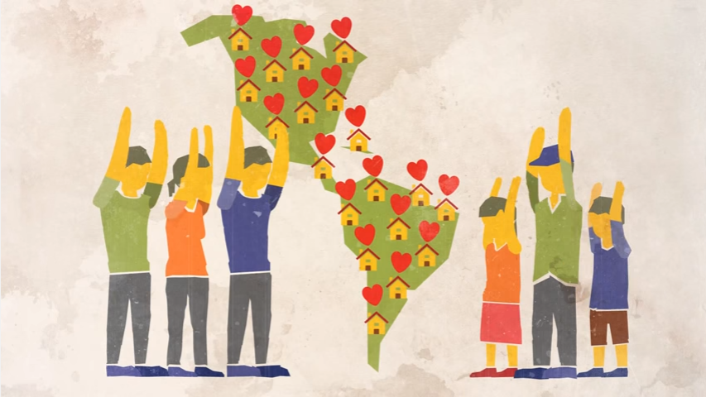I. Complete the next chart related to the content of the video “*América Solidaria: 10 Years in the Americas*” with the proper information from it.

|  |  |
| --- | --- |
| Name of the institution |  |
| Countries involved |  |
| Main projects |  |
| Beneficiaries |  |
| Future challenges |  |

II. Answer the next questions related to the content of the video “*América Solidaria: 10 Years in the Americas*” with the proper information, your personal opinion and knowledge from it. (Responde las siguientes preguntas relacionadas con el contenido del video “América Solidaria: 10 años en las Américas” con la información adecuada, tu opinión personal y el conocimiento del mismo.)

a) What is America Solidaria?

_____________________________________________________________________

b) What kind of projects do they have?

_____________________________________________________________________

c) How America Solidaria ensures their work?

_____________________________________________________________________

d) How does America Solidaria works?

_____________________________________________________________________

e) How many people are benefited with America’s Solidaria work per year?

__­__________________________________________________________________