Reading Nº6

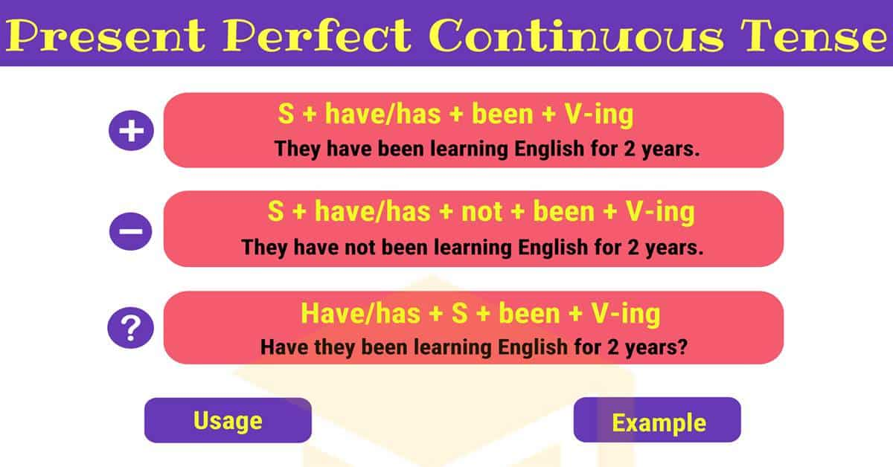

[**https://www.youtube.com/watch?v=VrhzLG-59lo**](https://www.youtube.com/watch?v=VrhzLG-59lo)

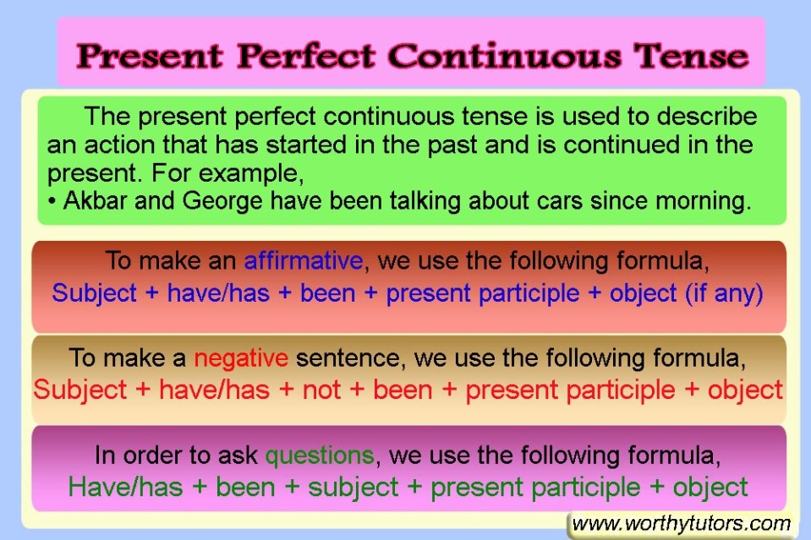

I. Writethe proper tenses by using the Present Perfect Continuous tense for the next sentences from the text *“What have they been doing…?”*

***“What have you been doing…?***



*“Lexi and Matt ________________* (date) *for about six months. Usually, they spend a lot of time together, but lately they ________________* (fight)*. Matt ________________* (spend) *a lot of time with Lexi’s best friend Gina, which ________________* (put) *Lexi in a very bad mood. Lexi is worried they are more than just friends. She ________________* (feel) *very stressed out about Matt and Gina.*

*What Lexi doesn’t know, however, is that Matt and Gina really are just friends. In fact, Matt and Gina ________________* (plan) *a surprise party for Lexi’s 19th birthday! Matt ________________* (invite) *people to the party secretly. Gina ________________* (order) *party favors, a cake, and finger food, all without Lexi knowing. She* (look) *for a band to play Lexi’s favourite music at the party. Soon enough, Lexi will find out that she ________________* (worry) *for no reason!”*

II. Completethe next sentences with the proper verb from the box for each sentence by using the Present Perfect Continuous verb tense.

**Work – read – play – rethink – study – talk – wait**

a) Sarah ___________________________ to her students for an hour.

b) They ____________________________ this problem.

c) Jonas ___________________________English since last year.

d) The children ______________________________ in the yard since eight o´clock.

e) Those men _______________________________ for a long time in that factory.

f) We ______________________________ for Ted for an hour.

g) I ____________________________ short stories for one month.

III. Create the next interrogative sentence forms for the next Present Perfect Continuous tenses and answer with the proper affirmative or negative sentence form depending on the exercise.

a) Joan / travel / six weeks

Question: _____________________________________________________________

Answer: (Affirmative): ____________________________________________________

b) Jeffrey / sing in this band / 2009

Question: _____________________________________________________________

Answer: (Negative): ____________________________________________________

c) Your grandmother / sit in the garden / lunchtime

Question: _____________________________________________________________

Answer: (Affirmative): ____________________________________________________

d) Stephanie / wait at the airport / for two hours

Question: _____________________________________________________________

Answer: (Negative): ____________________________________________________

e) We / play with the smartphone / the whole weekend

Question: _____________________________________________________________

Answer: (Affirmative): ____________________________________________________

IV. Look at Joe´s family. Each member of his family is somewhere in the house. Writethe proper sentence related to each picture about what do these people have been doing in the specific place.



a) b) c) d) e)

a) Mr. Stuart is in the family room. _________________________________________

b) His wife, Martha, is in the kitchen. ________________________________________

c) His grandfather is in the garden. _________________________________________

d) Bob, his brother, is in the bedroom. ______________________________________

e) Cathy, his sister, is in her bedroom. _______________________________________