Reading Nº8

Tema: Preguntas acerca del futuro

Name: _________________________________________________________________________________________

Objetivo: Comprensión lectora acerca del futuro.

I. Read the next paragraphs about the prediction of life in the future in the year 2116 and answer the exercises and questions below. (Lea los siguientes párrafos sobre la predicción de la vida en el futuro en el año 2116 y responda los ejercicios y preguntas a continuación.)

***“What life will be like in 2116”***

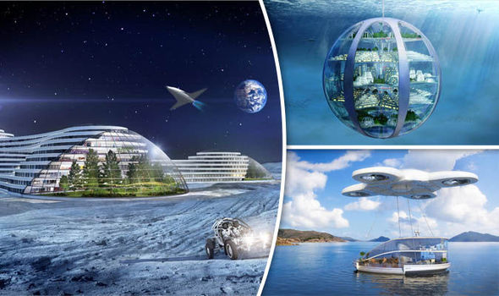*“A new report shows what life might be like in 100 years from now. It describes skyscrapers that are much taller than today's buildings, underwater 'bubble' cities, and holidays in space. The report is from Samsung's SmartThings. It asked experts on space, architecture, and city planners to give their ideas on life in 2116. They said the way we live, work and play will be totally different to how we do these things today. The experts said that 25 years ago, people could not imagine how the Internet and smartphones would change our lives. The Internet has revolutionized the way we communicate, learn and do daily things. The experts said the changes in the next century would be even more unbelievable.*

*Researchers questioned 2,000 adults about the predictions they thought were most likely to happen in the future. They predicted that in the future, few people will go to an office but will work from home and have virtual work meetings. People will have advanced 3D printers that will let you download a design for furniture or a food recipe and then 'print' the sofa, table or pizza at home. There will also be less need for visits to the doctor. We will all have a home health capsule that will tell us what the problem is and give us treatment. We will also be going into space for holidays and to get resources that we have used up on Earth. A prediction that was missing was whether people would still need to study English.”*

II. Answer the next questions about the content from the text “What life will be like in 2116” with the content from the text properly. (Responde adecuadamente las siguientes preguntas sobre el contenido del texto “Cómo será la vida en el año 2116” con el contenido del texto.)

a) How internet and smartphones have changed our lives?

_____________________________________________________________________

b) How will jobs and working characteristics be in the future?

_____________________________________________________________________

c) How will health and care be in the future?

_____________________________________________________________________

III. Choose TRUE ( T ) or FALSE ( F ) for the next statements related to the content from the text “What life will be like in 2116” properly. (Elija VERDADERO ( V ) o FALSO ( F ) para las siguientes afirmaciones relacionadas con el contenido del texto “Cómo será la vida en 2116” correctamente.)

a. Buildings in the future will be shorter than today's buildings. T / F

b. Experts say people will be living in underwater cities. T / F

c. The report is from the tech company Apple. T / F

d. Experts say the changes to come by 2116 will be unbelievable. T / F

e. Researchers asked 20,000 people about the future. T / F

f. People will be able to print download and print pizzas. T / F

g. People won't need to go to the doctor as much as they do now. T / F

h. People predicted that we will still need to study English. T / F

IV. Answer the next questions with your personal opinion and the content from the text “What life will be like in 2116” with the proper structure of the questions about the future mentioned in the lesson. (Responde las siguientes preguntas con tu opinión personal y el contenido del texto “Cómo será la vida en 2116” con la estructura adecuada de las preguntas sobre el futuro mencionadas en la lección.)

a) What will you do if you live in a bubble city?

_____________________________________________________________________

b) How will you feel when you work in virtual offices?

_____________________________________________________________________

c) What will you do when you get ill in the future?

_____________________________________________________________________

d) How will you feel if you live in the year 2116?

_____________________________________________________________________