Writing Nº10

Tema: Verbos modales

Objetivo: comprender el uso de los verbos modales.

I. Complete the next sentences by writing the proper modal verb for each case and context provided in each sentence. (Completa las siguientes oraciones escribiendo el verbo modal adecuado para cada caso y contexto proporcionado en cada oración.)

a) You _________ wake up early to go to school.

b) They ________ visit the downtown museum.

c) I __________ be more careful with my stuff.

d) I ________ to go to the supermarket.

e) I ________ study more to get a better grade.

f) She _________ move somewhere else, she doesn’t like the town.

g) He ___________ quit cooking classes, he is such a bad cook!

h) You _________ know about the rules of the game.

i) We _________ not smoke here.

j) Karl ___________ arrive soon.

II. Create a sentence related to the “*Environment and its care”* by giving the next statements using the proper modal verbs. (Crea una oración relacionada con “El Medio ambiente y su cuidado dando las siguientes afirmaciones utilizando los verbos modales adecuados.)

a) Recommendation: ____________________________________________________

b) Advice: _____________________________________________________________

c) Certainty and Necessity: _______________________________________________

d) Strong recommendation: _______________________________________________

e) Obligation: __________________________________________________________

III. Recognize the situation of the next pictures and write one suggestion, necessity or strong recommendation for each situation. (Reconoce la situación de las siguientes imágenes y escribe una sugerencia, necesidad o recomendación fuerte para cada situación.)



a) _____________________________________________________

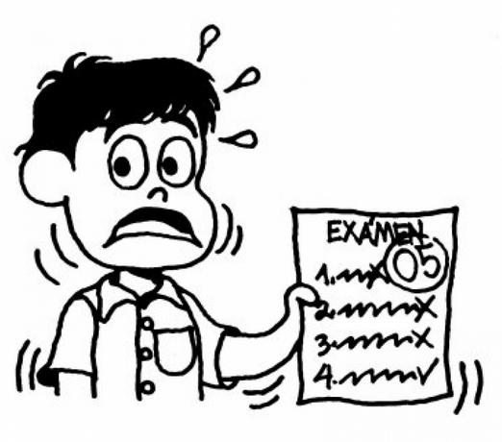

b) __________________________________________________

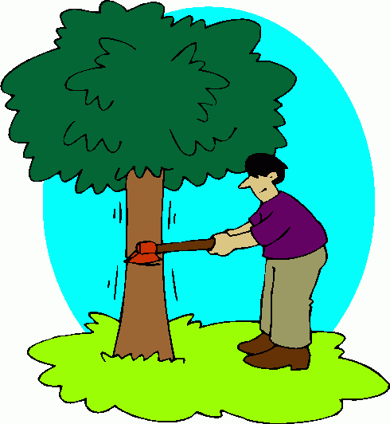

c) _____________________________________________________

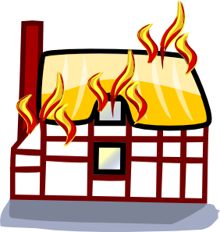

d) _____________________________________________________



e) _____________________________________________________