Colegio Particular Subvencionado “Sao Paulo” Asignatura: Lenguaje y Comunicación
Placilla 333, Estación Central Profesor: Luis Pineda Martínez
Unidad Técnico Pedagógica Curso: 5° Básico
Unidad 5:” La Magia del Género Narrativo”
Lectura: 55:” Creación Literaria III”

Actividad: A continuación, encontrarás los siguientes personajes, a los cuales deberás hacerles una descripción poética. Esta descripción es física y psicológicamente. Los personajes son:

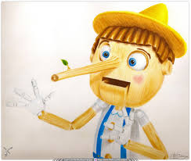
Pinocho: _________________________________________________________________________________
_____________________________________________________________________________________________________________________________________________________________________________________________________________________________________________________________________________________________________________________________________________________________________________________________________________________________________________________________________________________________________________________________________________________________________________________________________________________________________________________________________________________________________________________________________________________________________________________________________________________________________________________________________________________________________________________________________________________________________________________________________________________________________________________________________________________________________________________________________________________________________________________________________________________________________________________________________________________

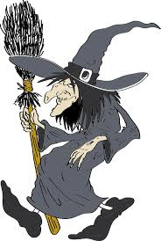
Bruja: ___________________________________________________________________________________
____________________________________________________________________________________________________________________________________________________________________________________________________________________________________________________________________________________________________________________________________________________________________________________________________________________________________________________________________________________________________________________________________________________________________________________________________________________________________________________________________________________________________________________________________________________________________________________________________________________________________________________________________________________________________________________________________________________________________________________________________________________________________________________________________________________________________________________________________________________________________________________________________________________________________________________________________________________________________________________________________________________________________

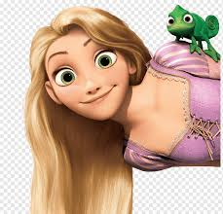
Rapunzel: _____________________________________________________________________________
__________________________________________________________________________________________________________________________________________________________________________________________________________________________________________________________________________________________________________________________________________________________________________________________________________________________________________________________________________________________________________________________________________________________________________________________________________________________________________________________________________________________________________________________________________________________________________________________________________________________________________________________________________________________________________________________________________________________________________________________________________________________________________________________________________________________________________________________________________________________________________________________________________________________________________________________________________________________________________________________________________

