Listening Nº1
Objective | Identificar las palabras que dan instrucciones a la clase.
Nombre
Tema: Instrucciones de la clase

I.- Find the hidden words referring to the class instructions. (busca las palabras escondidas referentes a las instrucciones de la clase.)

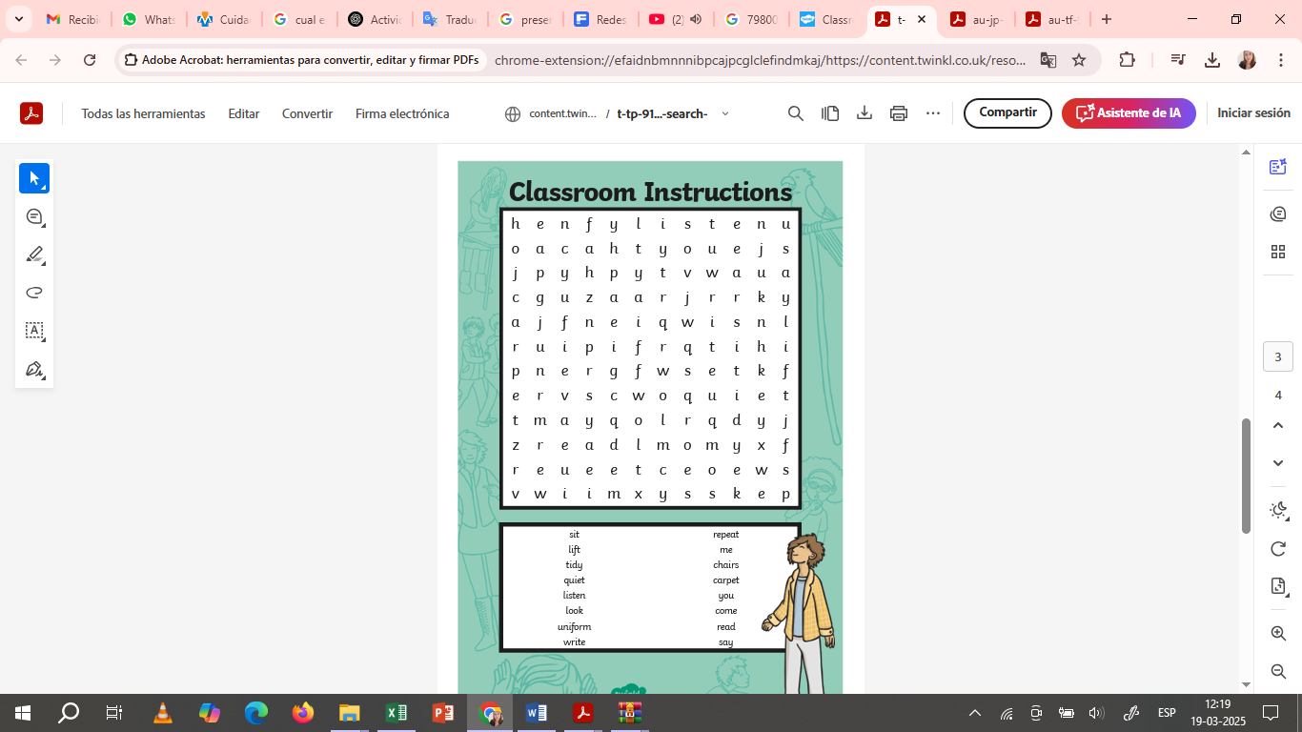
II.- Look for the meaning of these words referring to class instructions. (Busca el significado de estas palabras referentes a las instrucciones de clase.)
take out - put away - clean off - stand up - sit down - wipe off- May I…

_______________________________________________________________________________________________
_______________________________________________________________________________________________
_______________________________________________________________________________________________
_______________________________________________________________________________________________
_______________________________________________________________________________________________
_______________________________________________________________________________________________
_______________________________________________________________________________________________
_______________________________________________________________________________________________
_______________________________________________________________________________________________
_______________________________________________________________________________________________
_______________________________________________________________________________________________
_______________________________________________________________________________________________
_______________________________________________________________________________________________
_______________________________________________________________________________________________
_______________________________________________________________________________________________
_______________________________________________________________________________________________
_______________________________________________________________________________________________
_______________________________________________________________________________________________

