Listening Nº2
Objective | Identificar vocabulario de la ropa y los colores.
Name
Tema: “La ropa ”

I.- Read and Color. (Lee y colorea)

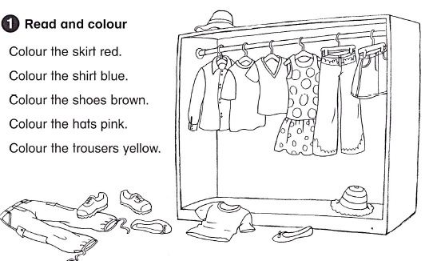

What did you wear today? (¿Que vistes hoy?)

_____________________________________________________________________
_____________________________________________________________________
_____________________________________________________________________

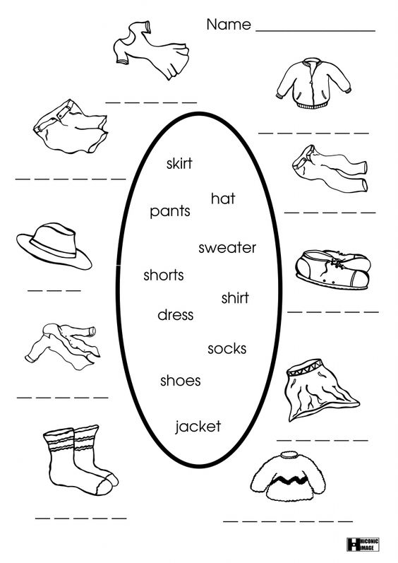
II.- Read and Complete. (Lea y complete)

