Listening Nº2

Tema: Sentimientos y personalidades

|  |  |
| --- | --- |
| Objetivo | Aprender y utilizar vocabulario relacionado con emociones y personalidades en inglés. |
| Nombre |  |

1. Identify vocabulary about feelings and emotions. (Identifique el vocabulario sobre sentimientos y emociones.)

Friendly Easy going Ambitious Generous

Creative Kind Hard Working Upset

1. Peter seems to be an _____________ person, he never worries about something.
2. My dad is very _____________, he doesn’t want me to go out.
3. She is helping that old woman; she seems to be a _____________ woman.
4. Thank you for helping us with the money! You are very _____________.
5. I can always count with your advice Sara, you are a _____________ person.
6. Look at these building! It’s amazing! The architect is a _____________ professional.
7. John wants to stay at work a few hours more, he is very _____________.
8. If you want to reach your goals, you have to be an _____________ person!

II.- Match the words with their meaning in Spanish. (Relaciona las palabras con su significado en español.)

1. Happy → ________
2. Shy → ________
3. Excited → ________
4. Lazy → ________
5. Brave → ________
6. Nervous → ________

III.- Complete the sentences with the correct word. (Completa las oraciones con la palabra correcta.)

1. She always tells jokes. She is very __________. (funny / serious)
2. I have an exam today. I feel __________. (brave / nervous)
3. He never helps at home. He is __________. (lazy / hardworking)
4. My best friend is very __________. She always helps me. (kind / angry)
5. He loves to meet new people. He is very __________. (shy / friendly)

IV.- Written Expression: Describe how you feel today and your personality. (Expresión Escrita: Describe cómo te sientes hoy y tu personalidad.)

Escribe 4-5 oraciones sobre cómo te sientes hoy y cómo es tu personalidad. Ejemplo: *Today I feel happy because it is a sunny day. I am friendly and kind. I like to help my friends and I love to laugh.*

________________________________________________________________________________________________________

________________________________________________________________________________________________________

________________________________________________________________________________________________________

________________________________________________________________________________________________________

________________________________________________________________________________________________________

________________________________________________________________________________________________________

V.- Actividad Extra

Juego de Mímica: En grupos, un estudiante debe actuar una emoción o personalidad mientras los demás intentan adivinar en inglés.

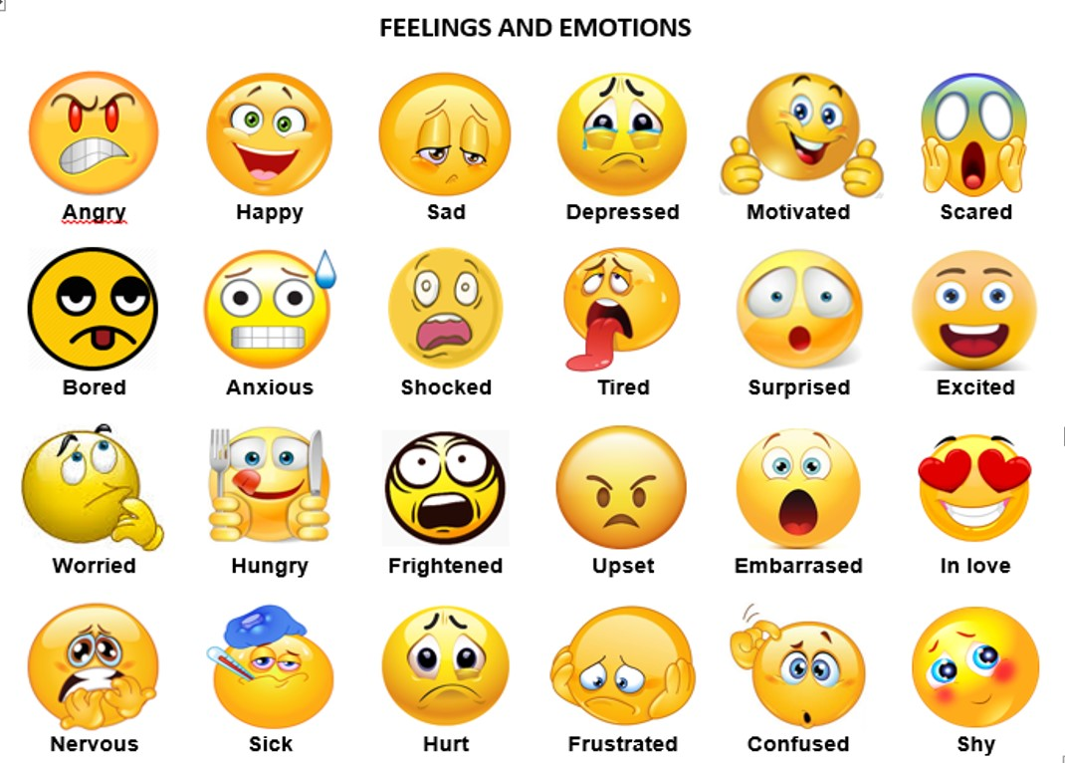VI.- Reflexión Final

* ¿Cuáles son las diferencias entre emociones y personalidades?
* ¿Cómo describirías a un amigo usando estas palabras?