Reading Nº1

|  |  |
| --- | --- |
| Contenido | Medios de Comunicaciones |
| Objetivo | Reflexionar sobre la actualidad de los medios de comunicación y la tecnología. |
| Instrucciones | Lee el artículo “El rol y la influencia de los medios de comunicación” y luego responde TRUE si es verdadero o FALSE si es falso.  Puede utilizar diccionario y/o cuaderno con la materia realizada en clases. |

Tema: “Medios de comunicación”

THE ROLE AND INFLUENCE OF MASS MEDIA

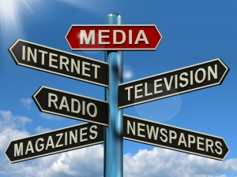“In the last five decades the media and its influence on the societies has grown exponentially with the advance of technology.

First there was the telegraph and the post offices, then the radio, the newspaper, magazines, television and now the internet and the new media including palmtops, cell phones etc. There are positive and negative influences of mass media, which we must understand as a responsible person of a society.

The function of the media in a society is to provide news and information to the masses, which is why the present era is some time termed as the information age as well. People need news/information for various reasons, on one hand it can be used to socialize and on the other to make decisions and formulate opinions.

In present era of globalization, majority of people in the society depends on information and communication to remain connected with the world and do our daily activities like work, entertainment, health care, education, socialization, travelling and anything else that we have to do. A common urban person usually wakes up in the morning checks the TV news or newspaper, goes to work, makes a few phone calls, eats with their family or peers when possible and makes his decisions based on the information that he has either from their co-workers, TV news, friends, family, financial reports, etc. we need to be conscious of the reality that most of our decisions, beliefs and values are based on what we know for a fact, our assumptions and our own experience.

We have put our trust on the media as an authority to give us news, entertainment and education. However, the influence of mass media on our kids, teenagers and society is so big that we should know how it really works. The media makes billions of dollars with the advertising they sell and that we are exposed to, every single moment. We buy what we are told to buy by the media. After seeing thousands of advertisings, we make our buying decisions based on what we saw on TV, newspapers or magazines. These are the effects of mass media especially in teenagers, they buy what they see on TV, what their favorite celebrity advertises and what is acceptable by society based on the fashion that the media has imposed on them. The media has a huge impact on society in shaping the public opinion of the masses. They can form or modify the public opinion in different ways depending of what is the objective.

There are some positive and negative influences in young people of our society due to these ad campaigns in the media. Here is a positive influence example, if there is a quiz show on education that is getting a lot of attention by the media and gains popularity among your friends and society, you will more likely want to actively participate and watch these quiz shows. These activities are good for the society and will promote literary activities in the youth. However, a negative influence in teenagers is the use of guns and ammunition by celebrity movie stars, the constant exposure of which would seduce the teen to replicate the same behavior in the real life.

II. ChooseTRUE or FALSE for the next exercises by finding the information in the text. (Elige TRUE si es verdadero o FALSE si es falso.)

a) The first media is the telephone. TRUE / FALSE

b) Socializing is the most important aspect of Mass Media. TRUE / FALSE

c) Mass media helps to get important information and communication. TRUE / FALSE

d) Advertising has been affected by the media negatively. TRUE / FALSE

e) Teenagers use Mass Media in order to be accepted. TRUE / FALSE

f) Obesity is not a media problem in the USA. TRUE / FALSE

g) Media doesn’t affect the public opinion of the masses. TRUE / FALSE

h) People learn through Mass Media. TRUE / FALSE

i) This age is called the Communication age. TRUE / FALSE

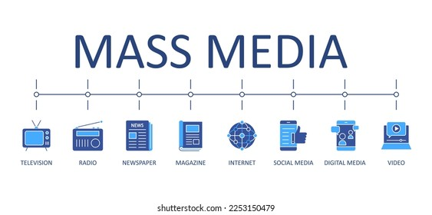j) Media affects our buying decisions in many ways. TRUE / FALSE

**Escribe en tu cuaderno un resumen del texto acerca de los medios de comunicación**