Reading Nº1

Tema: “Presente Perfecto”

|  |  |
| --- | --- |
| Objetivo | Comprender, identificar y utilizar el vocabulario relacionado al contexto del tiempo verbal “Presente Perfecto”. |
| Name |  |
| Instrucciones | Lea la información acerca el presente perfecto para luego realizas las actividades siguientes. Para que quede más clara la información del presente perfecto observe y escuche el video acerca del presente perfecto. <https://www.youtube.com/watch?v=iPK3hnx_BbI>  En el primer ítem debe escribir en los espacios en blanco con la forma correcta del verbo en presente perfecto. En el segundo ítem debe elegir la forma verbal correcta. |

El tiempo presente perfecto es usado para hablar de un evento que empezó en el pasado y que continua en el presente y finalizara en un futuro.

Ex: Luisa ha vivido en Francia por 2 años

Luisa has lived in France for 2 years.

PRESENT PERFECT

Ella ha comenzado a vivir en Francia hace 2 años y aún sigue allí.

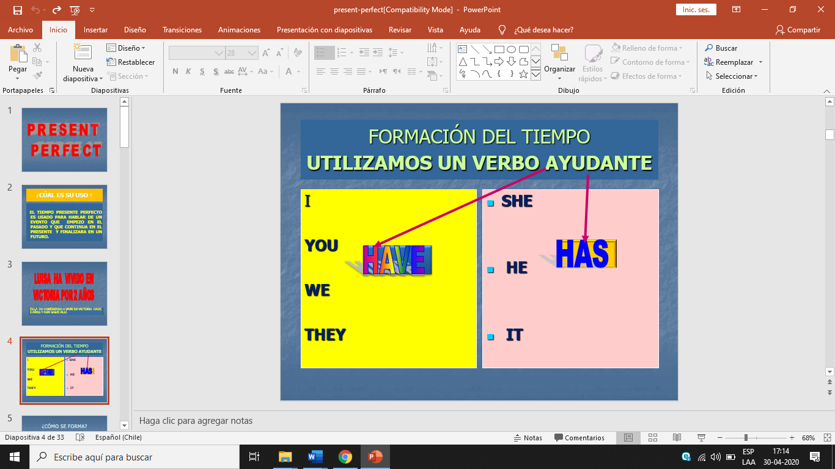

* Yo he vivido en Napoles

I have lived in Napoles

* Ella ha vivido en Temuco

She has lived in Temuco

* She has eaten pizza / she’s eaten pizza
* You have eaten pizza / you’ve eaten pizza

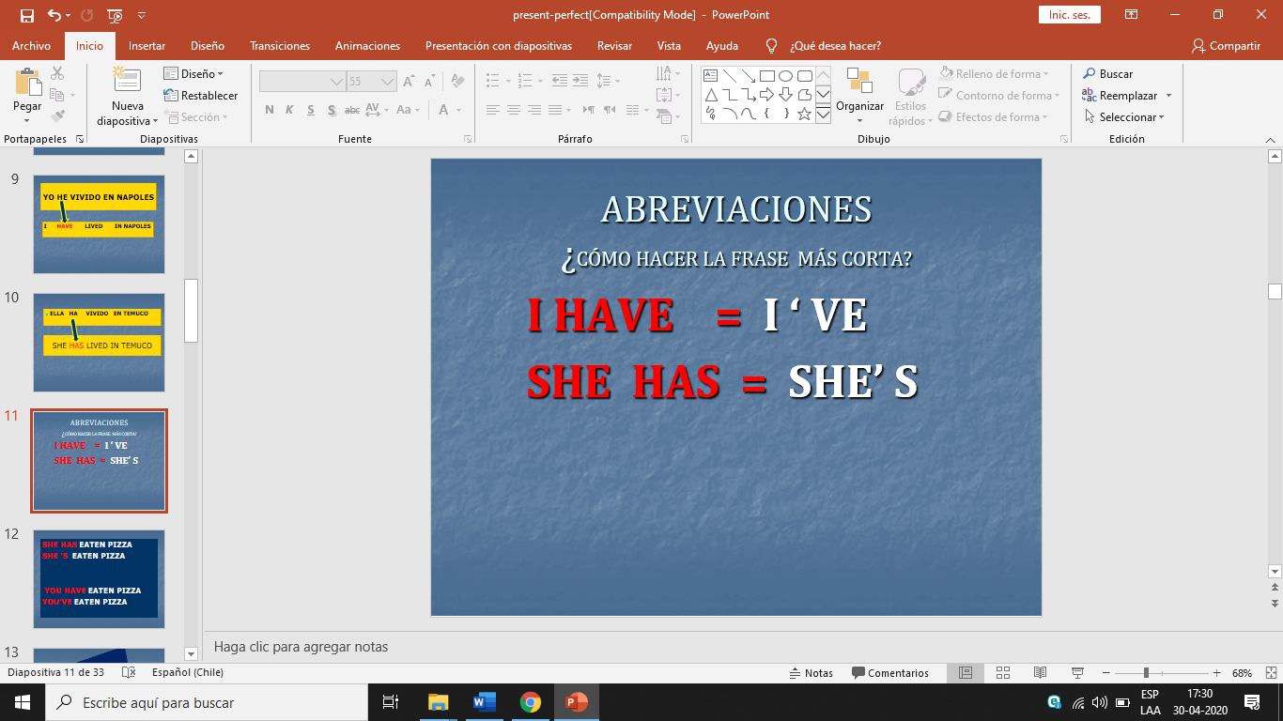

* **El verbo** debe ir en pasado participio, como en español diríamos: cantaba. reía. Estudiaba, etc. En esa forma del verbo, se le llama pasado participio.

* I have finished my work
* She has worked for me
* They have arrived on time
* It has drunk a glass of milk
* I have played tennis

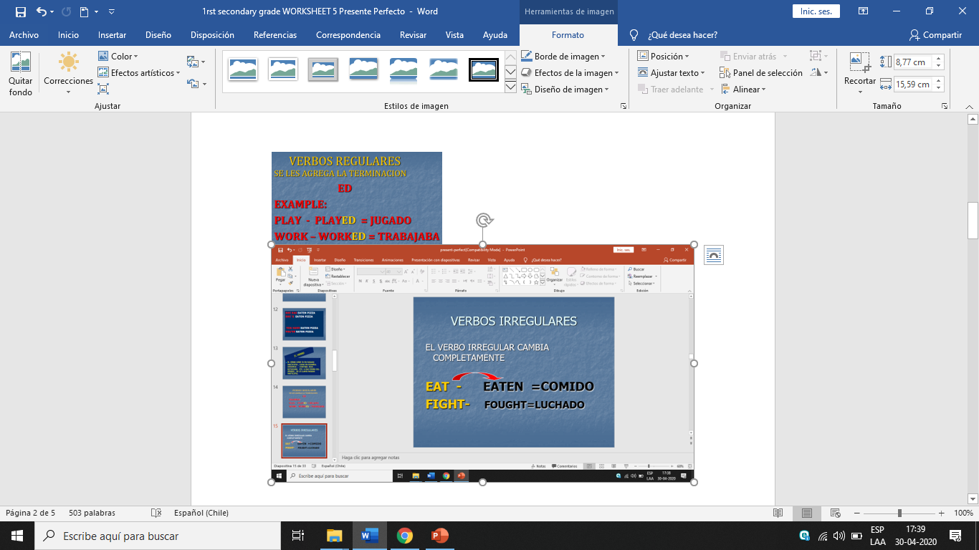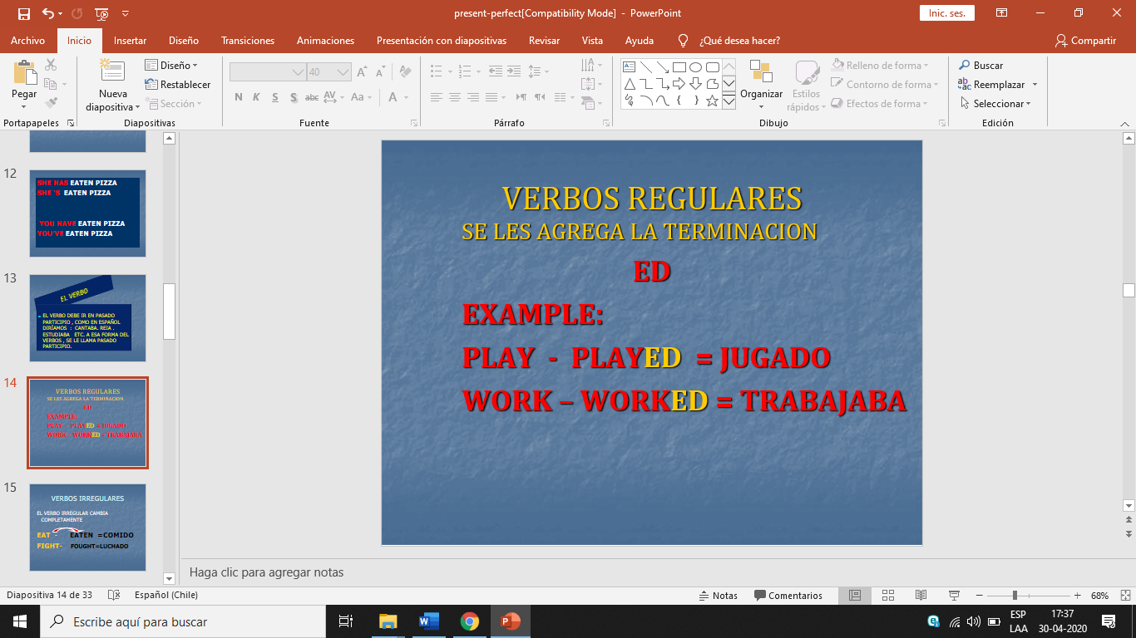

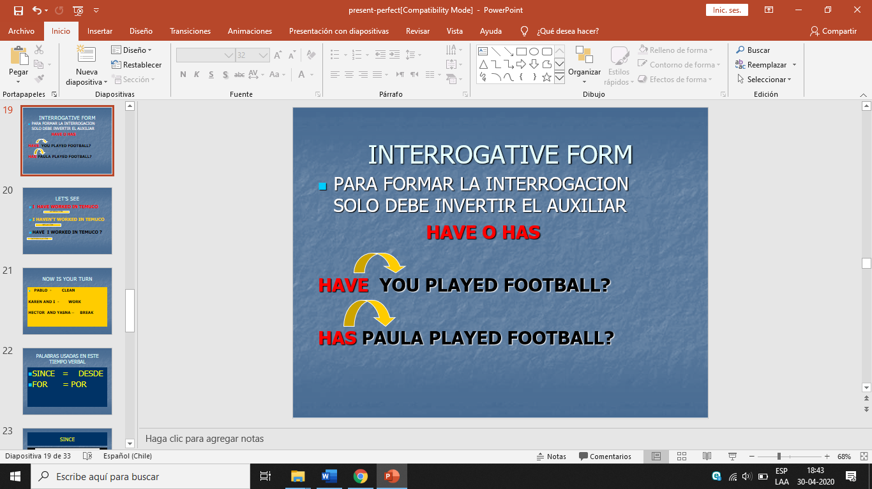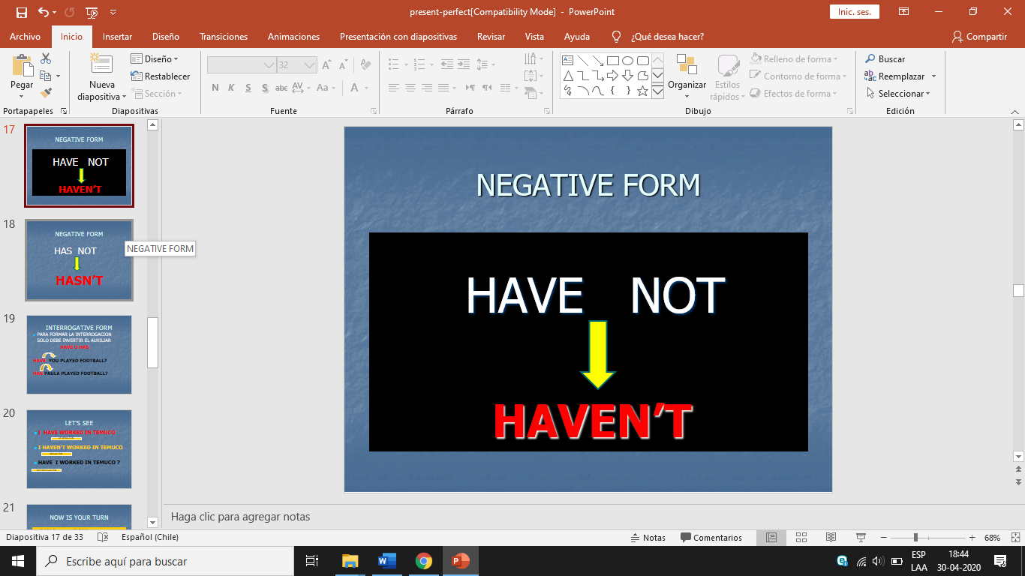

Exercises

I. Write in the spaces with the correct form of the verb in simple present perfect tense. (escriba en los espacios con la forma correcta del verbo en presente simple perfecto.)

1) Mark (eat) _______ ________ dinner already. He is not hungry.

2) Beth (not write) _______ ________ three letters today. She misses her family.

3) Yoko and Armand (take) _______ ________ the test. Now they can relax.

4) Marty and I (be) _______ ________ to Costa Rica three times. We are familiar with the culture.

5) I (drink) _______ _______ six cups of water today.

6) Eva (not sing) _______ ________ in a chorus before. Her voice is pretty.

7) You (show) ________ _________ that you are a hard worker. Good job!

8) Daisy (not wear) _______ _________ a dress to work every day this week.

II. Put the correct verb form. (Poner la forma verbal correcta.)

|  |  |  |
| --- | --- | --- |
| 1. Jenny and you _____________ listened 2. Has 3. Have 4. For 5. Since | 1. I _____________ thrown 2. Has 3. do 4. Since 5. Have | 1. They _____________ hoped 2. Does 3. Have 4. For 5. Has |
| 1. She _____________ drunk 2. Does 3. Have 4. For 5. Has | 1. It _____________ changed 2. Does 3. Have 4. Has 5. Since | 1. You _____________ eaten 2. Has 3. Have 4. For 5. Since |
| 1. Paul and me _____________ watched 2. Has 3. Do 4. For 5. Have | 1. We _____________ got 2. Has 3. Have 4. For 5. Since | 1. I _____________ played 2. Has 3. Does 4. For 5. Have |
| 1. It _____________ closed 2. Do 3. Have 4. Has 5. Since | 1. John _____________ taken 2. Has 3. Have 4. For 5. Since | 1. María _____________ fought 2. Has 3. Have 4. For 5. Has |