Reading Nº1

Tema: Practicando el Presente Perfecto

|  |  |
| --- | --- |
| Objective | Los estudiantes utilizarán el **Presente Perfecto** para leer y escribir sobre experiencias, logros y cambios en sus vidas y en el mundo. |
| Name |  |

I.- Complete the Sentences. Complete the following sentences with the correct form of the verb in the Present Perfect. Use have or has as appropriate. (Completa las siguientes oraciones con la forma correcta del verbo en Presente Perfecto. Usa *have* o *has* según corresponda.)

a) I _______________________________(travel) to three different countries this year.  
b) She _________________________________________________ (never / try) sushi before.  
c) They ____________________________________________ (live) in this city for ten years.  
d) We ___________________________________________________ (watch) that movie twice.  
e) He _______________________________________________ (not finish) his homework yet.

II.- Answer in at least two sentences using the Present Perfect. (Responde en al menos dos frases utilizando el Presente Perfecto.)

1. What is something you have never done but would like to try?

__________________________________________________________________________________

__________________________________________________________________________________

1. Have you ever met a famous person? Describe the experience.

__________________________________________________________________________________

__________________________________________________________________________________

1. How has technology changed the way we communicate?

__________________________________________________________________________________

__________________________________________________________________________________

1. What are three important things you have learned this year?

__________________________________________________________________________________

__________________________________________________________________________________

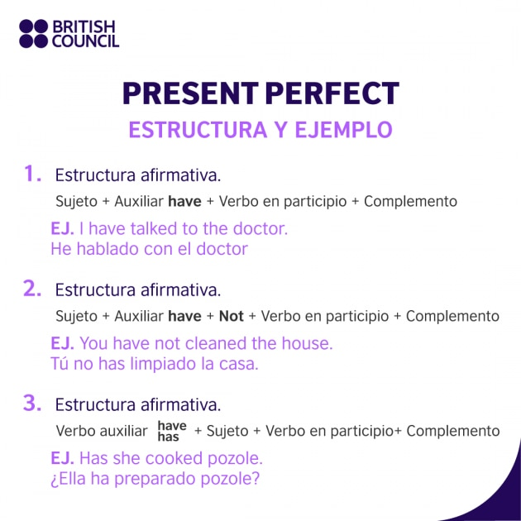

III.- Part 3: Write a short text. Write a 100-150 word paragraph about “The most important experiences I have had in my life.” Use the Present Perfect to describe significant experiences and how they have impacted you. (Escribe un texto corto. Escribe un párrafo de 100-150 palabras sobre “The most important experiences I have had in my life”. Usa el Presente Perfecto para describir experiencias significativas y cómo te han impactado.)

**Ejemplo de inicio:**  
*"I have had many important experiences in my life. For example, I have traveled to different places and learned about new cultures. I have also made great friends who have taught me valuable lessons…"*

|  |
| --- |
| ________________________________________________________________________________________________________  ______________________________________________________________________________________________________________________________________________________________________________________________________________________________________________________________________________________________________________________________________________________________________________________________________________________________________________________________________________________________________________________________________________________________________________________________________________________________________________________________________________________________________________________________________________________________________________________________________________________________________________________________________________________________________________________________________________________________________________________________________________________________________________________________________________________________________________________________________________________________________________________________________________________________________________________________________________________________________________________________________________________________________________________________________________________________________________________________________________________________________________________________ |

**Criterios de evaluación:**  
✔ Uso correcto del **Presente Perfecto**.  
✔ Claridad y coherencia en las respuestas.  
✔ Uso de vocabulario adecuado.  
✔ Creatividad y desarrollo del tema.