Reading Nº2

Tema: adjetivos relacionados con los Sentimientos y personalidades

|  |  |
| --- | --- |
| Objetive | Identificar y aplicar adjetivos relacionado con los sentimientos. |
| Name |  |

I. Pay attention to each picture and create a sentence for each exercise using the proper “feelings” vocabulary. (Presta atención a cada imagen y crea una oración para cada ejercicio utilizando el vocabulario de “sentimientos” adecuado.)

Sad Confident Thoughtful Peaceful

Shy Angry Happy Worried



a) _____________________________________________________



b) _____________________________________________________



c) _____________________________________________________



d) _____________________________________________________



e) _____________________________________________________



f) _____________________________________________________

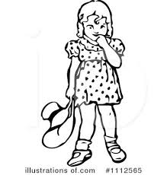

g) _____________________________________________________



h) _____________________________________________________

I.- Complete the sentences with an adjective then translate to Spanish. (Complete las oraciones con un adjetivo luego traducir al español.)

|  |
| --- |
| Good – bad – old – new – young – tall – short – long - big – small – expensive –cheap – nice– beautiful – handsome – ugly – clean – dirty – comfortable – interesting – intelligent – happy- sad – difficult – easy – fat – thin – poor – rich – delicious |

1- My chair is _____________________________________ = _____________________________________

2- My classmate is _____________________________________ = _____________________________________

3- The ruler is _____________________________________ = _____________________________________

4- The classroom is_____________________________________= _____________________________________

5- The lesson is _____________________________________ = _____________________________________

6- The rabbits are _____________________________________ = _____________________________________

7- The students are _____________________________________ = _____________________________________

8- The girls are _____________________________________ = _____________________________________

9- The car is _____________________________________ = _____________________________________

II.- Complete with an adjective. (Complete con un adjetivo.)

Example:

She is a beautiful singer.

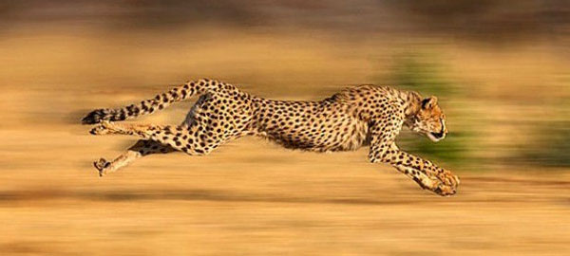

It is a ________________________ animal.

He is an ___________ person.

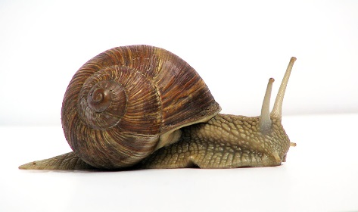

The snail is a ____________animal.

III.- Correct the sentences according to the pictures



1. Hanna is happy

………………………………………

1. He is tall and she is short

……………………………………………



1. She is fat

……………………………………

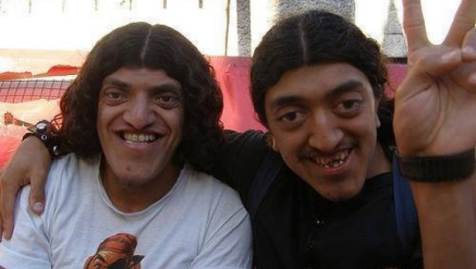

1. They are handsome

………………………………………..

IV.- Describe these people using adjectives. (Describe a estas personas usando adjetivos.)





















