Speaking Nº1
Tema: Presentación personal (Todo sobre mi)
Objective | Comprender información personal.
Nombre
Instructions | Completa el texto con tu propia información luego comparte la información con tu compañero de clases.

All About Me!
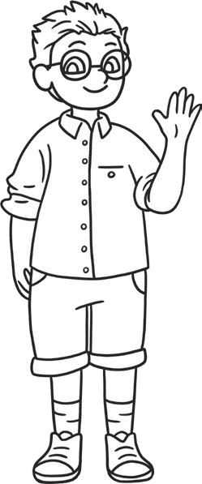
My Name is .
My Birthday is .
I am ______________ years old.
My favorite color is .
My favorite food is .
I live with my .
My brothers and sisters are called
.
Things that I am really good at are,
.
My favourite T.V programme is
Because .
When I grow up, I want to be

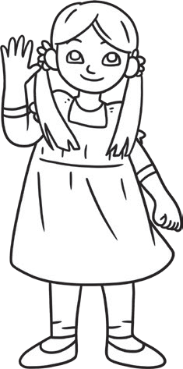
.
My best friend is called .

