Speaking Nº1

Tema: Buscando un trabajo

|  |  |
| --- | --- |
| Objective | Aprender acerca de la estructura y el contenido de avisos clasificados para ofertas de trabajo, e identificar cómo dichos avisos se dirigen con un objetivo claro a una audiencia específica. |
| Name |  |

I.- Answer the next questions:

* Have you ever worked in your life? Are you currently working on a part-time job?

________________________________________________________________________________________________

________________________________________________________________________________________________

* What do your parents/older siblings do? What are your parents’/older siblings’ jobs?

________________________________________________________________________________________________

________________________________________________________________________________________________

II.- Read the classified ads’ section from a newspaper. Individually, skim the text to look for available job positions that suit your interests and talents. (Leer la sección de anuncios clasificados de un periódico. Individualmente, revisar el texto para buscar puestos disponibles que se ajusten a sus intereses y talentos.)

Answer the following questions:

Why would those jobs be suitable for me?

________________________________________________________________________________________________

________________________________________________________________________________________________

Why would I be a good candidate?

________________________________________________________________________________________________

________________________________________________________________________________________________

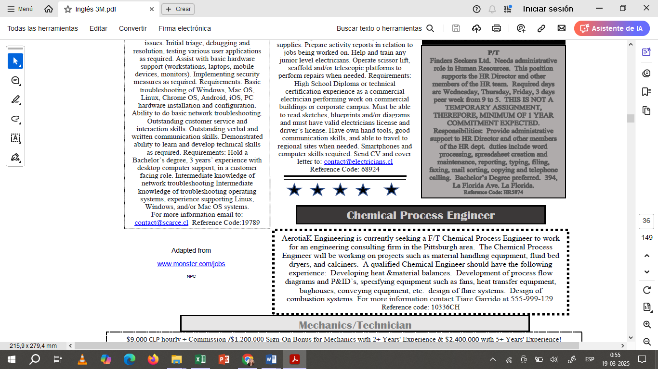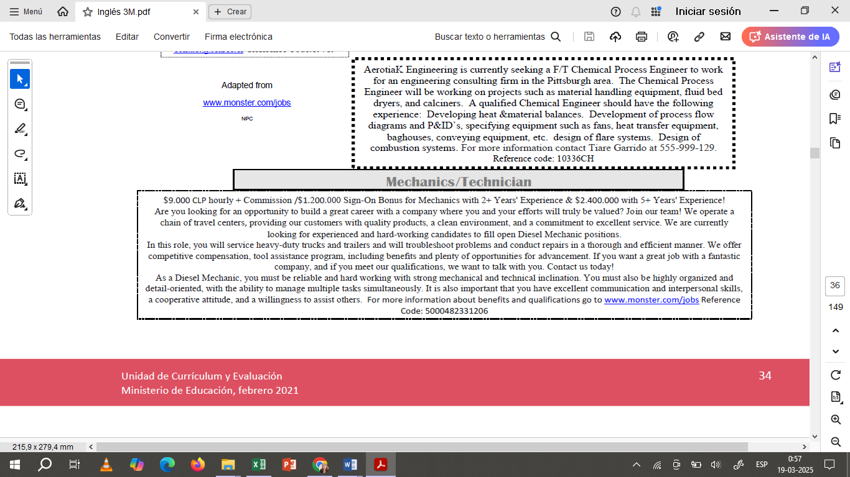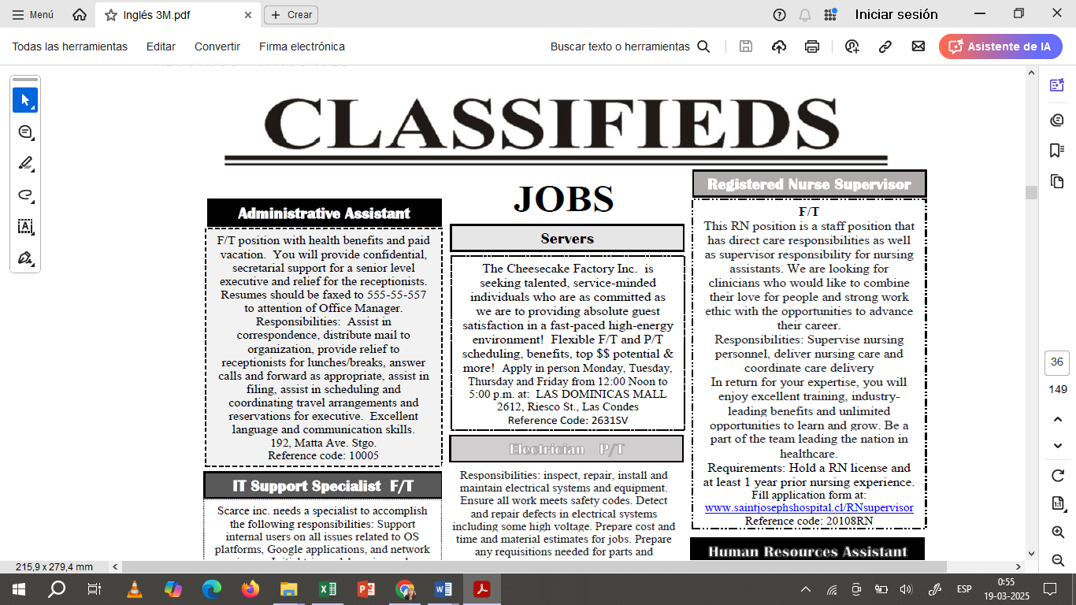

III.- Now, based on your two chosen classified ads, fill in the following chart in answer to the requirements inside each category. (Ahora, con base en los dos anuncios clasificados elegidos, complete el siguiente cuadro respondiendo a los requisitos dentro de cada categoría.)

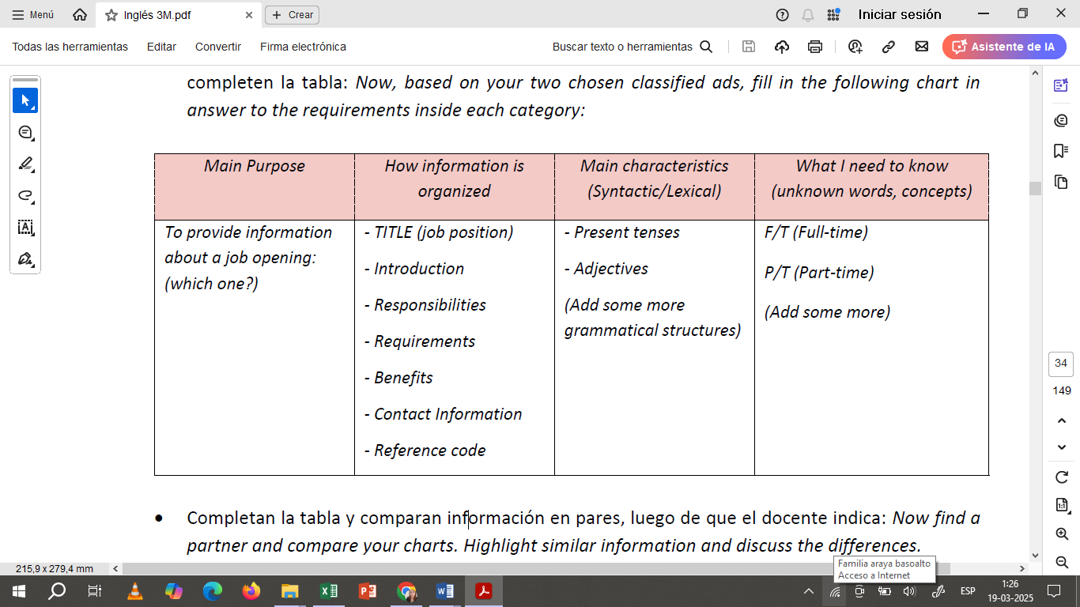

* En grupo de 4 a 5 estudiantes crear una infografía referente a los requerimientos del anuncio escogido y lo presentan a la clase.