Vocabulary Nº1
Objetivo | Identificar las reglas de la clase.
Nombre
Instrucciones | Observa las reglas de la clase y coméntalas con tus compañeros.
Tema: “Rules of the classroom – (Reglas de la clase)”

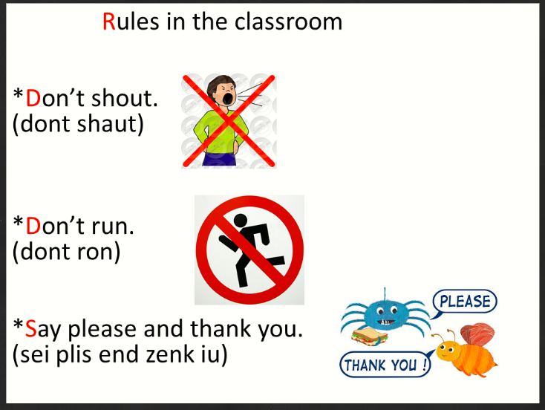
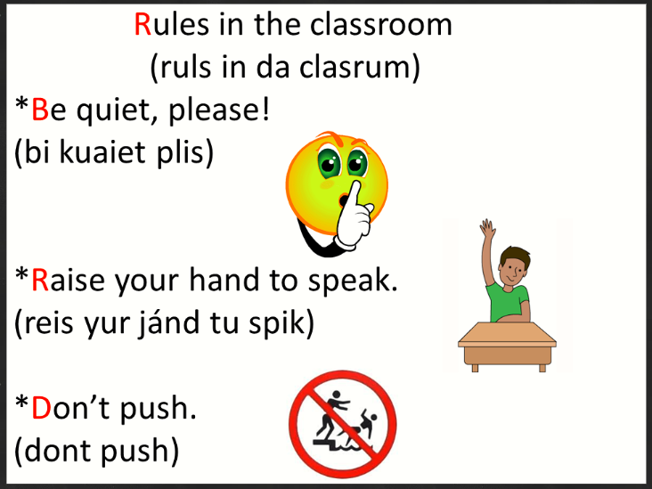

- Pronounce each rule correctly and then create three rules that we should include in our classroom.) (Pronuncia cada regla correctamente y luego crea tres normas que debamos incluir a nuestra sala de clases.)

1.
________________________________________________________________________________________________________________________________________________________________________________________________________________________________________________________________________________________

2.
________________________________________________________________________________________________________________________________________________________________________________________________________________________________________________________________________________________

3.
________________________________________________________________________________________________________________________________________________________________________________________________________________________________________________________________________________________

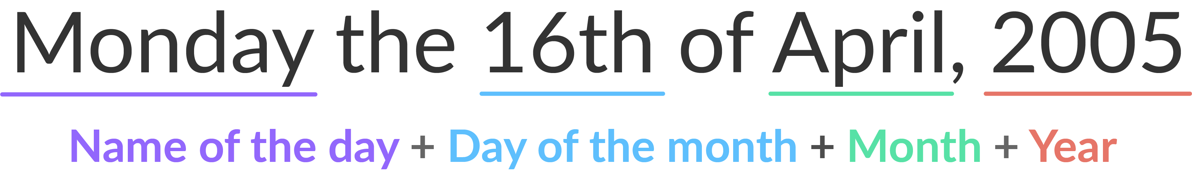

What is the date of today?
