Vocabulary Nº2
PAST SIMPLE TENSE


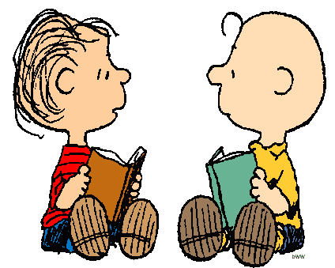
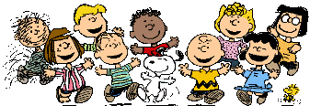
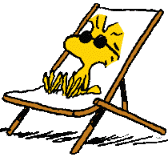
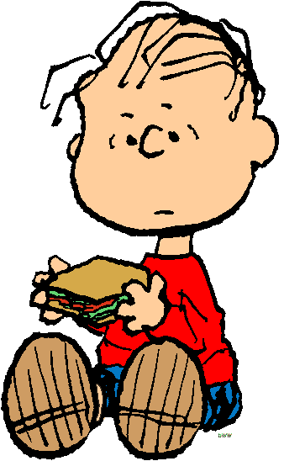
Put the verbs in brackets into the Past Simple Tense:

1. We ___________ (HAVE) a lot of fun at your
birthday party yesterday.
2. My brother and I ___________ (FINISH) our homework a few minutes ago.
3. Susan ___________ (LIKE) skating when she was a girl.
4. Joe ___________ (BREAK) his leg three weeks ago.
5. I ___________ (MEET) my best friend George in 2005.
6. My parents ___________ (GO) to the theatre yesterday evening.
7. He ___________ (WATCH) a very scary horror film last night.
8. Emma ___________ (NOT GO) to school when she was ill.
9. Where ___________ you ___________ (LEAVE) your jacket?
10. ___________ you ___________ (HATE) broccoli when you were a child?
11. Peter ___________ (READ) a very interesting book yesterday.
12. Mum ___________ (MAKE) a big chocolate cake a few hours ago.
13. We ___________ (PLAY) beach volleyball when we were at the seaside.
14. He ___________ (NOT LISTEN) to music after school yesterday.
15. I ___________ (GET) lots of good marks last month.
16. ___________ they ___________ (VISIT) their grandparents last summer?
17. He was very thirsty. He ___________ (DRINK) two glasses of water.
18. Sarah ___________ (NOT ENJOY) her piano lessons when she was seven.
19. Where ___________ your father ___________ (WORK) in 1985?
20. They ___________ (SEE) lots of animals in the zoo yesterday.

I made this sandwich two days ago.
We finished this exercise a few seconds ago.
REGULAR VERBS
+ + V ed / d
- + didn’t + V
? (Wh) Did + + V?
IRREGULAR VERBS
+ + II column
- + didn’t + I column
? (Wh) Did + + I column?

ADVERBS

►yesterday
►two days ago
►last week
►in March
►in 2003
►when I was younger

