Writing Nº2

Tema: ¿Cómo te sientes? (How do you feel?)

|  |  |
| --- | --- |
| Objective | Practicar vocabulario y estructuras relacionadas con la salud a través de ejercicios de escritura. |
| Name |  |
| Instructions | Lea atentamente las instrucciones de cada actividad y responda con atención y claridad. |

I.- Matching Symptoms and Diseases. Match each symptom with the corresponding disease. (Relacionar Síntomas y Enfermedades. Empareja cada síntoma con la enfermedad correspondiente.)

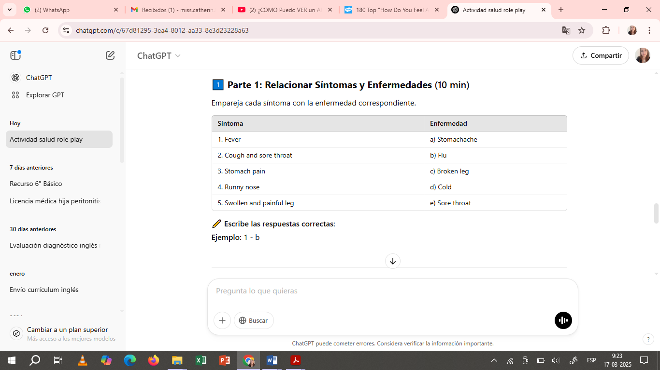

✏️ Write the correct answers: (Escribe las respuestas correctas)

Example: 1 – b

1. ___________________________
2. ___________________________
3. ___________________________
4. ___________________________
5. ___________________________

II. Complete the Dialogue. Fill in the blanks with the appropriate words: (feel, headache, doctor, cold, bad, medicine, tired). (Completar el Diálogo. Rellena los espacios con las palabras adecuadas: (feel, headache, doctor, cold, bad, medicine, tired)

🔹 **Patient:** Good morning, ________.  
🔹 **Doctor:** Good morning! What’s the matter?  
🔹 **Patient:** I ________ really ________. I have a terrible ________.  
🔹 **Doctor:** Do you have a fever?  
🔹 **Patient:** No, but I feel very ________ and have a ________.  
🔹 **Doctor:** You probably have a ________. You should take some ________ and rest.

✏️ Answer (**Responde):**

1. What advice did the doctor give?

2. What symptoms does the patient have?

__________________________________________________________________________

__________________________________________________________________________

__________________________________________________________________________

__________________________________________________________________________

III.- Mini Redacción – My Last Illness. Write a short paragraph (6-8 sentences) about the last time you were sick. Use health-related vocabulary. (Escribe un pequeño párrafo (6-8 oraciones) sobre la última vez que estuviste enfermo/a. Usa vocabulario relacionado con la salud).

**Incluye:**

• How did you feel?

• What symptoms did you have?

• What did you do to get better?

📌 **Ejemplo de inicio:** *Last month, I felt really sick. I had a terrible headache and a fever...*

|  |
| --- |
| _____________________________________________________________________________________________________ |

|  |
| --- |
|  |

Final del formulario