Writing Nº3

|  |  |
| --- | --- |
| Objetivo | Identificar y escribir en textos escuchados acerca del uso de Who o Whose. |
| Instrucciones | Observa y lea la estructura del uso de Who o Whose.  En el primer ítem los estudiantes deben escribir “who” o “whose” en cada oración correctamente al identificar el contexto y la intención de cada una de estas. En el segundo ítem los estudiantes contestan las siguientes preguntas con respuestas cortas utilizando los pronombres posesivos correctamente para cada ejercicio.  Los estudiantes revisan las preguntas de la lista A y las unen con la respuesta correcta de la lista B. Puede utilizar diccionario para estas actividades. |
| Recuerda | **WHOSE** para hablar de alguien a quien pertenece algo. Es un pronombre posesivo como his, hers o ours (SU).  **WHO** es un pronombre de sujeto como he, she o they (ÉL, ELLA o ELLOS).  <https://www.youtube.com/watch?v=uzx-mIErpbE> |

Tema: Preguntas “Who or Whose?”

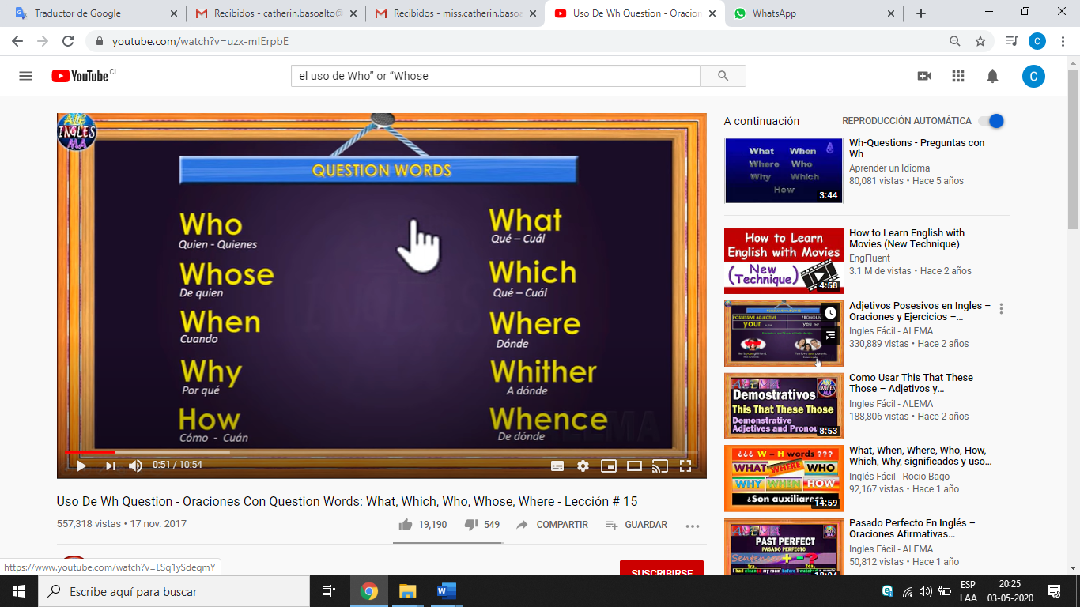

<https://www.youtube.com/watch?v=uzx-mIErpbE>

Se debe utilizar “Who” cuando nos referimos a alguien o cuando queremos conocer algo más sobre una persona.

* Who

Ejemplos:

* Miguel, the man **who** answered the phone, was not very helpful.

(Nos referimos a la persona que contestó el teléfono).

* Alright, **who** ate my apple pie?

(Queremos saber **quién** se comió el pie de manzana).

* Nico Nicolino, **who** was the former CEO, has just arrived.

(Ahora conocemos que Nico fue el director ejecutivo).

* María, **who** was my art teacher, is a wonderful actress.

(Sabemos que María fue profesora de arte).

El uso de “whose” indica alguna propiedad o pertenencia. Funciona como un “de quién” en las preguntas o como un “cuyo” (el adjetivo relativo posesivo) en las oraciones.

* Whose
* Whose bicycle is this? (Queremos saber **de quién** es esa bicicleta).
* There’s the musician whose old guitar was stolen. (Sabemos que ahí va el músico **cuya** guitarra fue robada).

Si tienes problemas para recordar su uso, solo debes aprender algo: el “whose” siempre se usa con sustantivos.

* This is Carol, **whose sister** went to college with me.
* A country **whose population** is mainly ignorant is doomed.
* I love people **whose attitude** to life is positive and courageous.

Exercises

I. Write “Who” or “Whose” in each exercise correctly by identifying the context and the intention of each sentence. (Escriba correctamente “Quién” o “Quién” en cada ejercicio identificando el contexto y la intención de cada oración.)

a) ________________ is the girl waiting for the bus? She is my friend Lola.

b) The patient ________________ husband was complaining was very pale.

c) ________________ is this baby? My sister’s.

d) The person ________________ rang the doorbell was wearing a red coat.

e) ________________ house is this? Polly’s

f) ________________ did you go to the cinema with? I went with Tom.

g) Tell me ________________ you are looking for and I'll try to help you.

h) _________________ umbrella is this? Mine is blue.

i) ________________ is the man sitting at my desk? The new boss.

j) The man ________________ house we stayed in is my uncle.

II. Answerthe following questions with short answers using the correct possessive form for each exercise. (Responda las siguientes preguntas con respuestas cortas utilizando la forma posesiva correcta para cada ejercicio.)

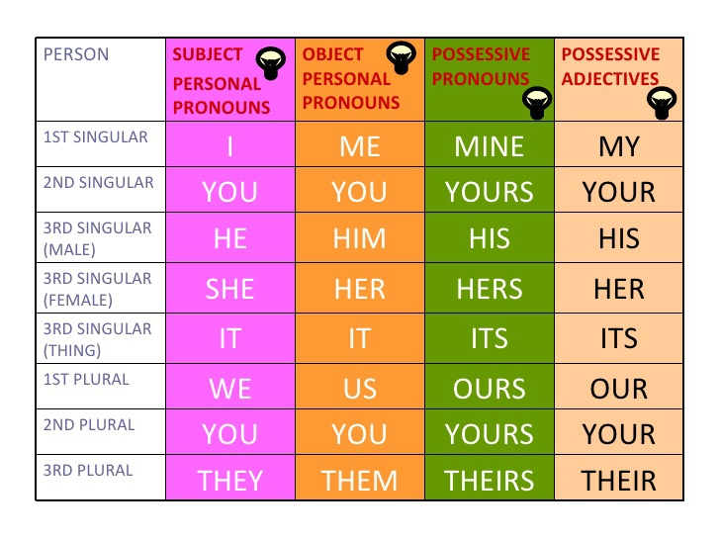a) Whose house is this? (Amy) ____________________________________________.

b) Whose money is this? (the bank) ___________________________________________.

c) Whose book is this? (the teacher) ___________________________________________.

d) Whose keys are these? (Ann) ___________________________________________.

e) Whose cars are these? (my friends) __________________________________________.

f) Whose food is this? (the dogs) ___________________________________________.

g) Whose dictionary is this? (Marco) ___________________________________________.

h) Whose hat is brown? (Jennifer) ___________________________________________.

i) Whose gloves are theses? (My friends and I) __________________________________.

j) Whose bicycle is red? (My bicycle) ___________________________________________.

III. Check the questions from the LIST A and match them with the correct answer of the LIST B. (Verifique las preguntas de la LISTA A y compárelas con la respuesta correcta de la LISTA B.)

|  |  |
| --- | --- |
| **LIST A** | **LIST B** |
| 1) Whose shoes are these? | _____ This pen is hers. |
| 2) Whose books are those? | _____ These glasses are hers |
| 3) Whose office is that? | _____ Those shoes are his. |
| 4) Whose socks are blue? | _____ That book is his |
| 5) Whose pen is this? | _____ That book is hers. |
| 6) Whose dog is big? | _____ That is Nick’s office. |
| 7) Whose computer is that? | _____ Esteban’ socks are blue. |
| 8) Whose car is red? | _____ Marco’s dog is big. |
| 9) Whose book is that? | _____ Those books are his. |
| 10) Whose glasses are these? | _____ Marcia’s car is red. |

