Lámina de resúmen

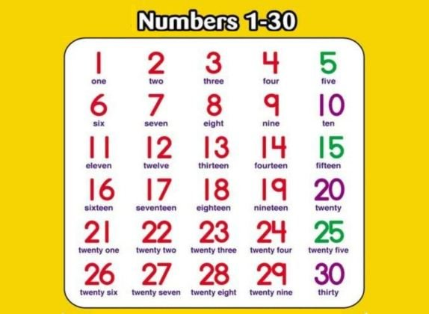Curso: 6° Básico

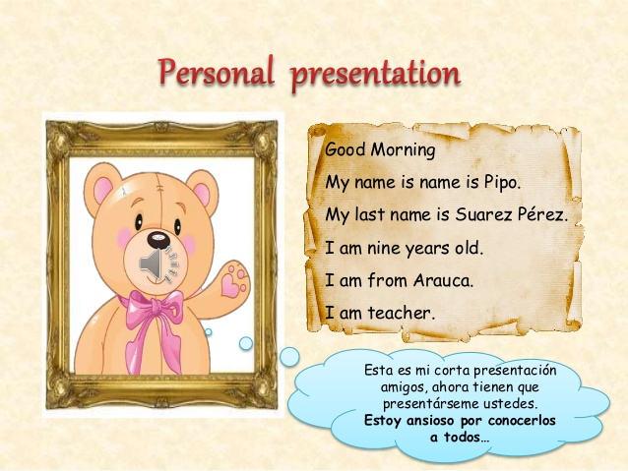

**FOOD VOCABULARY**

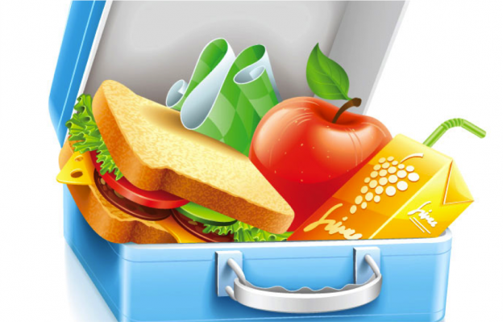

What does this picture have?

a)

This plate has an apple, a sandwich and juice.

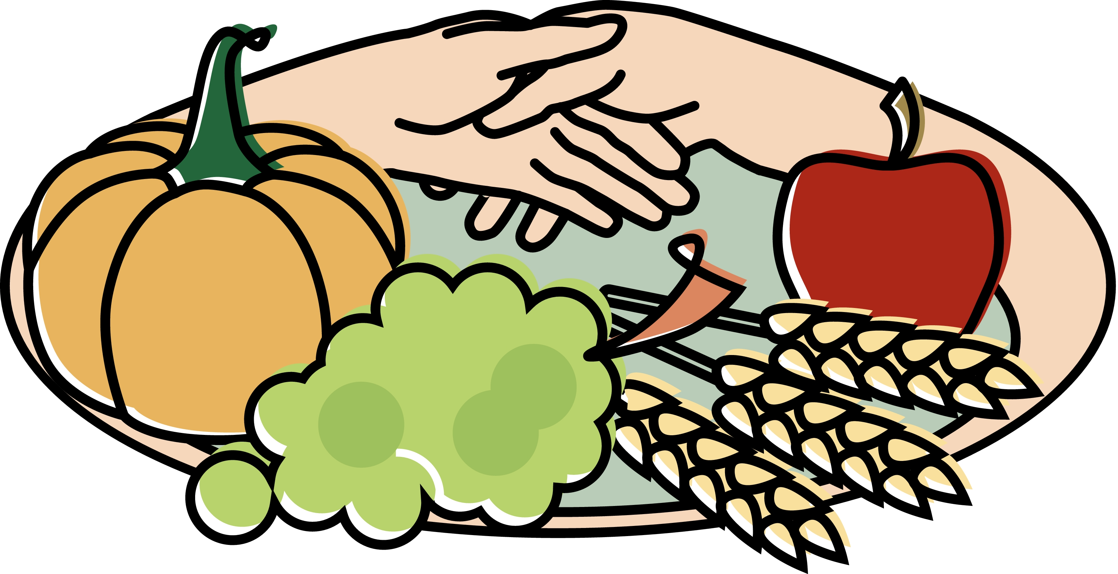

What does this picture have?

b)

This plate has a pumpkin, an apple, grapes and corn.

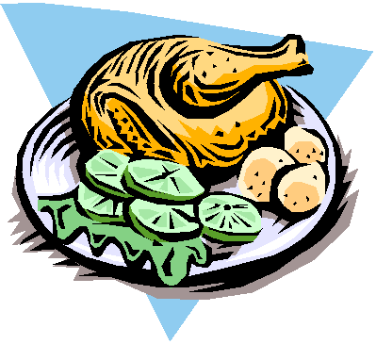

What does this picture have?

c)

This plate has a chicken, potatoes, lettuce and lemon.

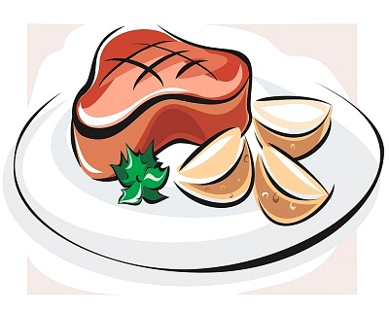

What does this picture have?

d)

This plate has potatoes and meat.

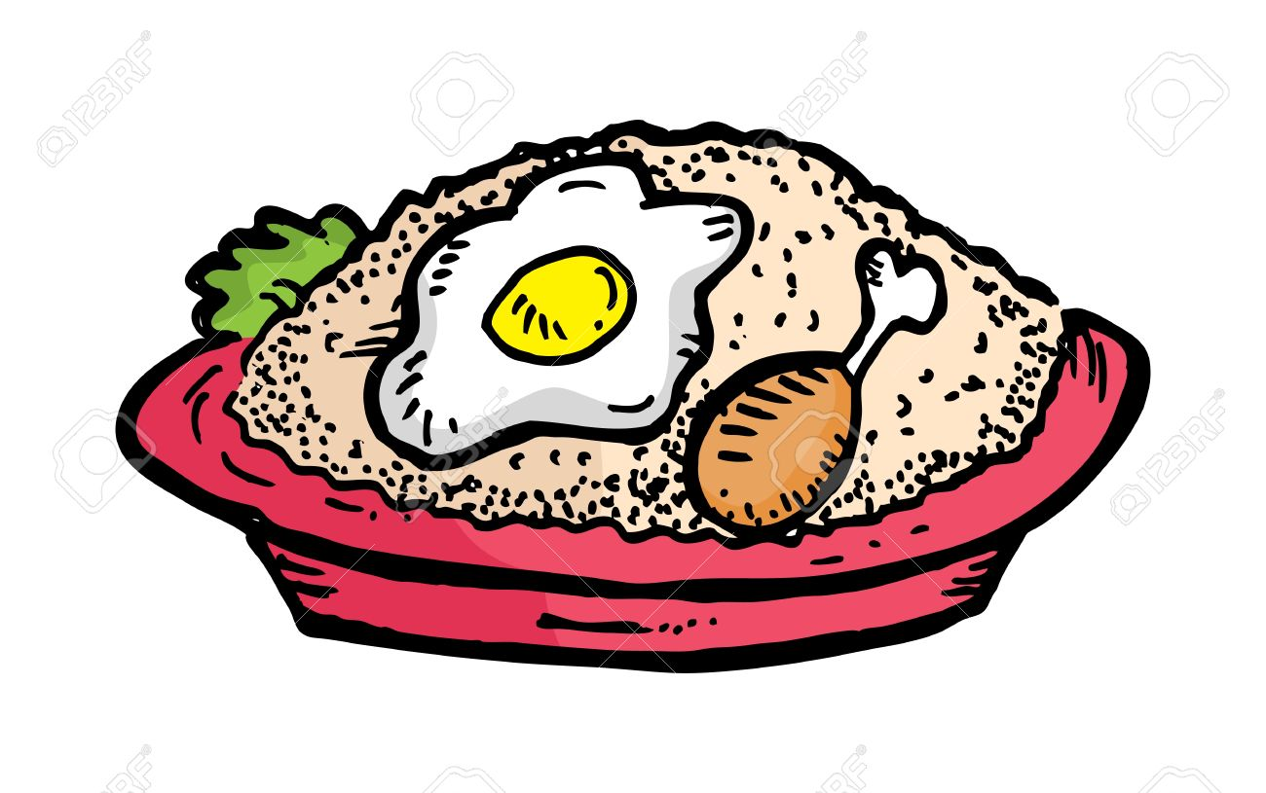

What does this picture have?

e)

This plate has rice, chicken and a fried egg.