Reading Nº3

Tema: Noticias

|  |  |
| --- | --- |
| Name |  |
| Objective | Reflexionar sobre la actualidad de las entrevistas de trabajo en inglés y lograr crear sus propias conclusiones. |

**Content: Job Interview…Good example.**

<https://www.youtube.com/watch?v=SieNfciN274>

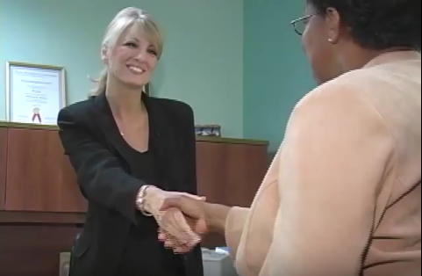

I. Watch and listen to the job interview that Tamara had with Stephanie and answer the next questions. (Observa y escucha la entrevista de trabajo que Tamara tiene con Stephanie y responde las siguientes preguntas.)

a) What position is Tamara interviewing for?

_____________________________________________________________________________________________________

b) Where did Tamara see this job position posted?

_____________________________________________________________________________________________________

c) What is the experience that Tamara has in Human Resources?

____________________________________________________________________________________________________

d) What qualities is Tamara looking for when she is interviewing someone?

____________________________________________________________________________________________________

e) How many chances will Tamara give to workers that are late in a period of six months?

__________________________________________________________________________________________________

f) What does Tamara’s co-workers say about her qualities?

__________________________________________________________________________________________________

g) What does Tamara need to improve a little better?

_________________________________________________________________________________________________

h) What does Tamara think it takes to be a good employee?

________________________________________________________________________________________________

i) Why does Stephanie need a new Human Resources Assistant?

_______________________________________________________________________________________________

II. Answer the next questions related to the content of the video and your personal analysis from it. (Responde las siguientes preguntas relacionadas con el contexto del video y su análisis personal sobre este.)

a) Is Tamara ready for the job? Why?

_______________________________________________________________________________________________________

_______________________________________________________________________________________________________

b) Is Stephanie interested on hiring Tamara? Why?

_______________________________________________________________________________________________________

_______________________________________________________________________________________________________

c) Would you hire Tamara? Why?

_______________________________________________________________________________________________________

_______________________________________________________________________________________________________

d) How Stephanie reacts to the answers that Tamara gave in the interview? Why?

_______________________________________________________________________________________________________

_______________________________________________________________________________________________________

e) What do you think about the interview? Was it good? Was it bad? Why?

_______________________________________________________________________________________________________

_______________________________________________________________________________________________________